Canada: Trade, Free Trade
- Who does Canada trade with?
- What is “free trade”?
- What are the implications of these factors?
- What influences government decisions in relation to trade?

- Who does Canada have “free trade” agreements with?

- Use the world map
- Identify and label each country and year in which the agreement came into effect
- http://www.international.gc.ca/trade-agreements-accords-commerciaux/agr-acc/fta-ale.aspx?lang=eng
- How many countries does Canada have some type of economic agreement with? __________________
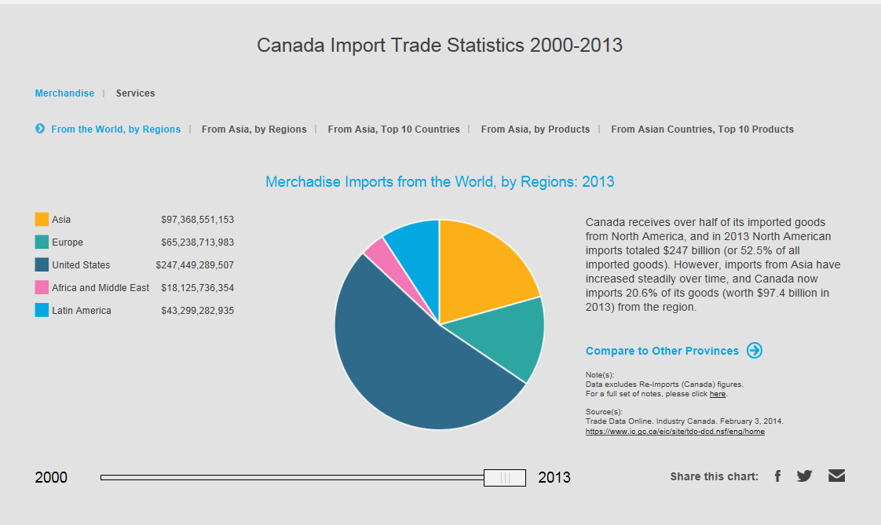

http://theasiafactor.ca/ca#e=0&e0=4&ccode=chn&scrollTo=e
- Examine the following charts that indicate Canada’s trade with China.
- What conclusions can you draw? (What is important about what you see?)
http://www.asiapacific.ca/statistics/trade/bilateral-trade-asia-product/canadas-merchandise-trade-china

