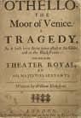
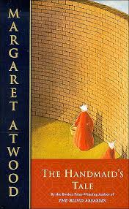
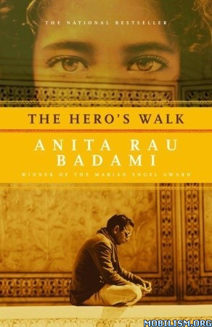
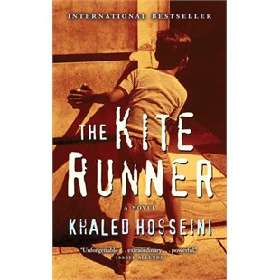
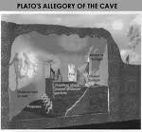
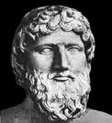
English 30-1
Mrs. Raymond
BCHS
January 2014-
June 2014
The Citadel Theatre Presents...May 28, 2014
Read, mark, learn, and inwardly digest.
(The Book of Common Prayer, 1662)

Key learning goals in English 30-1

- Students will read, write, listen, speak, view and represent to:
    - explore thoughts, ideas, feelings & experiences
    - comprehend texts; respond personally, critically, and creatively to texts (emphasis)
    - manage ideas and information
    - create texts; enhance clarity and artistry of communication (emphasis)
    - respect, support and collaborate with others

(Texts include: stories, novels, film, speech, monologues, poetry, documentary film, newspaper articles, songs….)

- Students will have an opportunity to communicate for a variety of purposes, in a variety of ways- communication is central in our lives (from texting to speaking to writing).
- Students will examine the role of literature in understanding who we are as individuals, as a society, and as members of the human race.
- Students will be encouraged to become “metacognitive”. That is, to become aware of their own learning strengths and challenges and to become stronger, independent, reflective learners.
- Students will be encouraged to read a variety of books- fiction and nonfiction in an effort to broaden knowledge, to build empathy, and to vicariously experience life in other places or time periods.

Units of Study

- Introduction: Goals. Why literature? Initial response. (2-3 days)
- Soldier’s Heart: modern play David French (1 week)
- The Kite Runner: novel study (2-3 weeks)
- Tuesdays with Morrie: Non-fiction (2 -3 weeks)
- Quick Writes: Weekly responses (ongoing)
- Archetypes: a thematic unit that explores short story and poetry (4 weeks)
- Visually Speaking: “Reading” photographs, paintings & responding (3 days)
- Finding Neverland: film study (3 days)
- Othello, William Shakespeare (2 weeks)
- Independent Novel Study: Students will choose from: Heroes Walk, The Handmaid’s Tale, Into the Wild, Wild Geese (2 weeks)

Materials Required
- Binder, pens, pencils, highlighters, sticky notes
- Memory stick, earbuds, library card
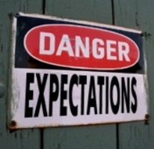
- Pencil crayons, glue, scissors for creative projects

Expectations
- Arrive on time.
- If you are late, come to class.
- Be prepared- materials with you, homework completed.
- Homework- complete what is asked of you. There is an expectation of two or more hours a week for this course.
- Assignments are due on the date assigned at the beginning of class.
- If you are not handing in an assignment, you must see me to arrange an appropriate extension.
- Respect the learning opportunities and environment.
- Work collaboratively with classmates.
- Students may request to redo an assignment by discussing this with me within one day of return of the assignment.
- Cheating/plagiarism: don’t do it! Possible consequences: redoing assignment, receiving a zero, removal from course.
- Be responsible: no excuses (I forgot- get a calendar, use your phone calendar; no ink-USB, GoogleDocs, Drop Box; I was away-see me asap!)

Assessment: How are you doing?

Formative Assessment: This is an important part of the work we will complete this year. Formative assessment is an ongoing process that allows the teacher (me) and students (you) an opportunity to work on learning. In an effort to make sure that you are learning, and that you have an opportunity to learn, improve, revise, we will establish some routines that allow for this.
- Not all work is marked.
- We will complete a variety of tasks in an effort to identify where you are, where you need to be, and how you will get there.
- I will offer feedback and you may ask for feedback at any point in the learning process.
- You will have opportunities to assess your own work and to set goals.

Marking/Grades

- I will clearly identify when a piece will be marked.
- I will clearly identify how a piece will be marked.

Class Mark: Based on the summative assessments work.

Final:
- Class mark 50%
- Diploma Exam 50%

Assessment in English 30-1

Formative Assessment | Summative Assessment
- Blog-contributions to the “conversation”  - Collaborative work  - Informal presentations  - Feedback provided by Mrs. Raymond on written responses  - Reflection on significant assessments (metacognition)  - Peer assessment: provide feedback to each other  - Literature circle collaborative groups  - Reading comprehension (multiple choice)  - Reading Log  - Soliloquy Assignment  - Bio Poem  - Literary Terms Review | - Critical/Analytical Responses (x3)  - Personal Responses (>4)  - Multimedia presentation  - Creative visual response  - Double Diary entry  - Bio poem

