Independent Book Study
- This time, you will have a choice about which book you will read.
- Format: meeting once a week, double-entry journal, mind map notes.
Book Choices:
- Into the Wild, Jon Krakauer (non-fiction)
- Mosquito Coast, Paul Theroux (fiction)
- Hero’s Walk, Anita Rau Badami (fiction)
- Wild Geese, Martha Ostenso (fiction)
- No Great Mischief, Allistair MacLeod (fiction)

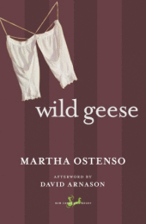
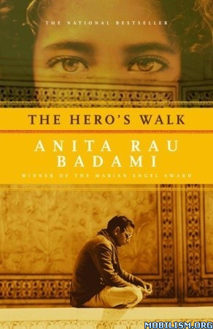

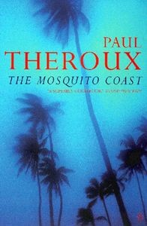
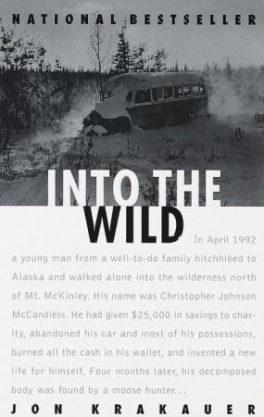

Assignments:
- Bio poem:
  - Write a bio poem about the key character.
  - Include a visual or visuals to enhance your meaning.
  - Include a written description of what you were hoping to accomplish, the choices you made, and the satisfaction you feel with the final product. DETAILED

- Critical/Analytical Essay
  - Choose one from the following topics.

Discuss the idea developed by the writer regarding the conflict between pursuing a personal desire and choosing to conform.

Discuss the idea developed by the writer regarding the role adversity plays in shaping an individual’s identity.

Discuss the idea developed by the writer regarding the effect that determination has on our approach to the pursuit of a goal.

- Carefully consider your controlling idea and how you will create a strong unifying effect.
- As you develop your ideas, support them with appropriate, relevant, and meaningful examples from your chosen text.
BioPoem
A BioPoem is a structured collection of vivid details about a character's life, personality traits and aspirations: a portrait in words. In creating your BioPoem, try to avoid generalizations, which tend to be boring and uninteresting, in favour of vivid details which reveal interesting aspects of your subject. The structure of the BioPoem you are going to use is outlined below. An example is also provided.
Begin each line with the words in quotes where indicated, and after research supply the details requested in the parentheses. Good luck!
Line 1: (Character's first name)
Line 2: "Relative of..." or Friend of..." (List 3 or 4 relatives or friends)
Line 3: (List 4 character traits that would describe this person or his personality
Line 4: (Position or job)
Line 5: "Lover of..." (3 things, people, activities, etc.)
Line 6: "Who felt..." (3 emotions and explanations)
Line 7: "Who has been..." (3 places or events this character has been)
Line 8: "Who needed..." (3 descriptions of things this character may have needed)
Line 9: "Who feared..." (3 descriptions of things this character may have feared)
Line 10: "Who gave..." (3 descriptions of what this character has given to family, friends, the world,
etc.)
Line 11: "Who longed for..." (3 descriptions)
Line 12: "Who would like to have seen..." (3 descriptions of things the character may have wanted to
have seen in his lifetime)
Line 13: (Synonym - one profound word that describes the character)
Line 14: "Resident of..." (description of place, dates, location, etc.)
Line 15: (Character's last name)
Winnie the Pooh
Winnie
Cheerful, optimistic, loyal, 'a bear of very little brain'
Friend of Piglet, Christopher Robin, Eeyore and Tigger
Teddy bear, friend, confidante and honey hunter
Lover of honey, impromptu songs and hums, honey and more honey
Who feels adventurous on expeditions, fearful of Woozles and protective of Piglet
Who fell out of a tree, got pulled into the air by a kite and walked in the 100 Acre Wood
Who needed advice from Christopher Robin, occasional mothering from Kanga and a 'little something' at 11:00
Who feared empty honey pots, Tigger's bounces and bees
Who gave Eeyore the house he already had, the game of Pooh-Sticks to his friends and unlimited love to
Christopher Robin
Who longed for more honey, to look like a cloud and fly
Who would like to have seen Christopher Robin remain a child forever, the return of 'small' and Eeyore
happy
Loveable
Resident of 100 Acre Wood and Christopher Robin's imagination
The Pooh
Book Choice:___________________________________
Chosen because…

Assignment:
- Complete two entries for each reading section.

- Find a passage from the book.
  - Write this in the left column.
  - In the right column, write your thinking, response, interpretation…

- Final Thoughts
  - Write a personal response

Double Entry Diary

Name: _____________________
Due Date: __________________

Section One: _____________________________________
Page #_______
Quote | Response  ____________________________________________________________________________________________________________________________________________________________________________________________________________________________________________________________________________________________________________________________________________________________________________________________________________________________________________________________________________________________________________________________________________________________________________________________________________________________________________________________________________________________________________________________________________________________________________________________________________________________________________________________________________________________________________________________________________________________________________________________________________________________________________________________________________________________________________________________________________________________________________________________________________________________________________________________________________________________________________________________________________________________________________________________________________________________________________________________________________________
Section One: _____________________________________
Page #_______
Quote | Response  ____________________________________________________________________________________________________________________________________________________________________________________________________________________________________________________________________________________________________________________________________________________________________________________________________________________________________________________________________________________________________________________________________________________________________________________________________________________________________________________________________________________________________________________________________________________________________________________________________________________________________________________________________________________________________________________________________________________________________________________________________________________________________________________________________________________________________________________________________________________________________________________________________________________________________________________________________________________________________________________________________________________________________________________________________________________________________________________________________________________
Section Two: _____________________________________
Page #_______
Quote | Response  ____________________________________________________________________________________________________________________________________________________________________________________________________________________________________________________________________________________________________________________________________________________________________________________________________________________________________________________________________________________________________________________________________________________________________________________________________________________________________________________________________________________________________________________________________________________________________________________________________________________________________________________________________________________________________________________________________________________________________________________________________________________________________________________________________________________________________________________________________________________________________________________________________________________________________________________________________________________________________________________________________________________________________________________________________________________________________________________________________________________
Section Two: _____________________________________
Page #_______
Quote | Response  ____________________________________________________________________________________________________________________________________________________________________________________________________________________________________________________________________________________________________________________________________________________________________________________________________________________________________________________________________________________________________________________________________________________________________________________________________________________________________________________________________________________________________________________________________________________________________________________________________________________________________________________________________________________________________________________________________________________________________________________________________________________________________________________________________________________________________________________________________________________________________________________________________________________________________________________________________________________________________________________________________________________________________________________________________________________________________________________________________________________

Section Three: _____________________________________
Page #_______
Quote | Response  ____________________________________________________________________________________________________________________________________________________________________________________________________________________________________________________________________________________________________________________________________________________________________________________________________________________________________________________________________________________________________________________________________________________________________________________________________________________________________________________________________________________________________________________________________________________________________________________________________________________________________________________________________________________________________________________________________________________________________________________________________________________________________________________________________________________________________________________________________________________________________________________________________________________________________________________________________________________________________________________________________________________________________________________________________________________________________________________________________________________

Section Three: _____________________________________
Page #_______
Quote | Response  ____________________________________________________________________________________________________________________________________________________________________________________________________________________________________________________________________________________________________________________________________________________________________________________________________________________________________________________________________________________________________________________________________________________________________________________________________________________________________________________________________________________________________________________________________________________________________________________________________________________________________________________________________________________________________________________________________________________________________________________________________________________________________________________________________________________________________________________________________________________________________________________________________________________________________________________________________________________________________________________________________________________________________________________________________________________________________________________________________________________

Section Four: _____________________________________
Page #_______
Quote | Response  ____________________________________________________________________________________________________________________________________________________________________________________________________________________________________________________________________________________________________________________________________________________________________________________________________________________________________________________________________________________________________________________________________________________________________________________________________________________________________________________________________________________________________________________________________________________________________________________________________________________________________________________________________________________________________________________________________________________________________________________________________________________________________________________________________________________________________________________________________________________________________________________________________________________________________________________________________________________________________________________________________________________________________________________________________________________________________________________________________________________

Section Four: _____________________________________
Page #_______
Quote | Response  ____________________________________________________________________________________________________________________________________________________________________________________________________________________________________________________________________________________________________________________________________________________________________________________________________________________________________________________________________________________________________________________________________________________________________________________________________________________________________________________________________________________________________________________________________________________________________________________________________________________________________________________________________________________________________________________________________________________________________________________________________________________________________________________________________________________________________________________________________________________________________________________________________________________________________________________________________________________________________________________________________________________________________________________________________________________________________________________________________________________

Personal Response: Final Thoughts
Now that you have finished the book, write a personal response.
- What is the key idea you take from this?
- What connection(s) can you make?
- Why is this idea important?
_________________________________________________________________________________________________________________________________________________________________________________________________________________________________________________________________________________________________________________________________________________________________________________________________________________________________________________________________________________________________________________________________________________________________________________________________________________________________________________________________________________________________________________________________________________________________________________________________________________________________________________________________________________________________________________________________________________________________________________________________________________________________________________________________________________________________________________________________________________________________________________________________________________________________________________________________________________________________________________________________________________________________________________________________________________________________________________________________________________________________________________________________________________________________________________________________________________________________________________________________________________________________________________________________________________________________________________________________________________________________________________________________________________________________________________________________________________________________________________________________________________________________________________________________________________________________________________________________________________________________________________________________________________________________________________________________________________________________________________________________________________________________________________________________________________________________________________________________________________________________________________________________________________________________________________________________________________________________________________________________________________________________________________________________________________________________________________________________________________________________________________________________________________________________________________________________________________________________________________________________________________________________________________________________________________________________________________________________________________________________________________________________________________________________________________________________________________________________________________________________________________________________________________________________________________________________________________________________________________________________________________________________________________________________________________________________________________________________________________________________________________________________________________________________________________________________________________________________________________________________________________________________________________________________________________________________________________________________________________________________________________________________________________________________________________________________________________

