A CBC documentary with Mark Kelly.
http://www.cbc.ca/fifth/episodes/2013-2014/made-in-bangladesh

- What responsibility do we have, as global citizens, for events that happen elsewhere?
- Outsourcing?
- Consumer activism?
- Corporate responsibility (transnationals)?
- Globalization, human rights & quality of life?
- Sustainability: economic, environmental, individuals & communities?
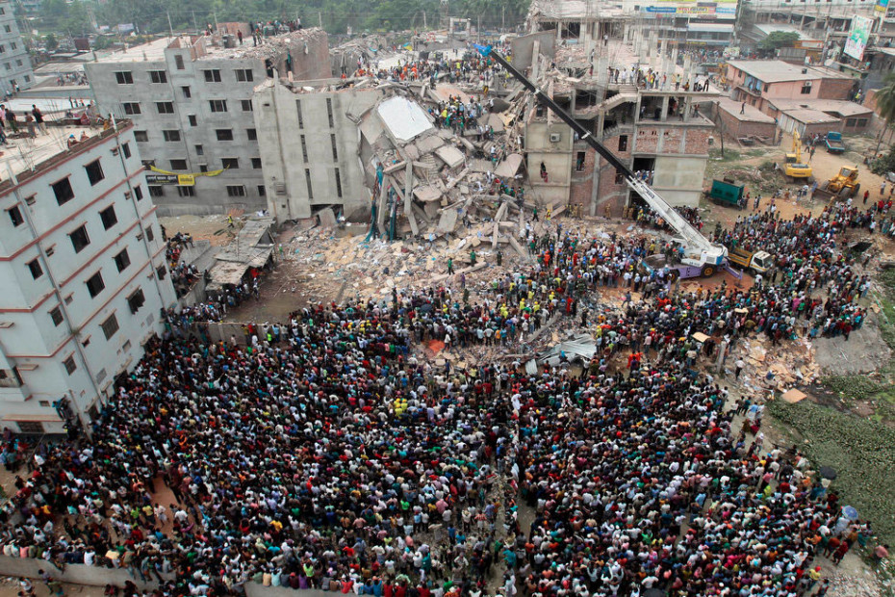

http://tinyurl.com/omkf6vc
Notes:

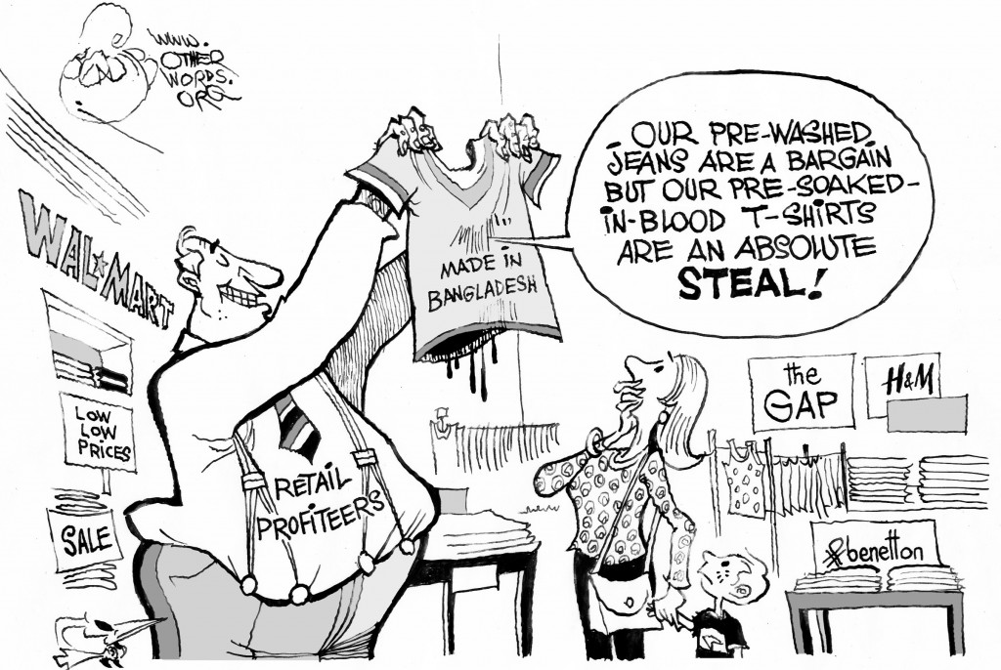
Source Analysis:

http://otherwords.org/made-in-bangladesh/
___________________________________________________________________________________________________________________________________________________________________________________________________________________________________________________________________________________________________________________________________________________________________________________________________________________________________________________________________________________________________________________________________________________________________________________________________________________________________________________________________________________________________________________________________________________________________________________________________________________________________________________________________________________________________________________________________________________________________________________________________________________________________________________________________________________________________________________________________________________________________________________
What are the alternatives?
- Read the attached article, “After the Savar tragedy”
- Read “The Grameen Bank”, Exploring Globalization, pg. 204-205
- Read “The Fair –Trade Movement”, Exploring Globalization, pg. 336-337
___________________________________________________________________

After the Savar tragedy, time for an international minimum wage
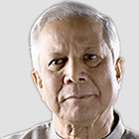
Bangladesh's garment industry must be reformed, not destroyed. Let's see foreign buyers unite to lift workers out of 'slave labour'
  - Muhammad Yunus
The Guardian, Sunday 12 May 2013 16.51 BS

Alam/Demotix/Corbis
For Bangladeshis, the tragedy at the garment factory in Savar is a symbol of our failure as a nation. The crack that caused the collapse of the building has shown us that if we don't face up to the cracks in our own systems, we as a nation will get lost in the debris. Today, the souls of those who lost their lives in Rana Plaza are watching what we are doing and listening to what we say. The last breath of those souls surrounds us.
Did we learn anything at all from this terrible loss of life? Or will we have completed our duty by merely expressing our deep sympathy? What should we do, now that news of a deadly fire in another factory in Dhaka reaches us?
Important questions have been raised about the future of the garment industry. Pope Francis has said buyers are treating the garment workers like slave labourers. A very large foreign buyer, Disney, has decided to pull out of Bangladesh. Others may follow. If that happens, it will severely damage our social and economic future. This industry has brought about immense change in our society by transforming the lives of women. We cannot allow it to be destroyed. Instead, Bangladeshis must be united as a nation to strengthen the garment industry, and foreign companies must play their part too.
I propose that foreign buyers jointly fix a minimum international wage for the industry. This might be about 50 cents an hour, twice the level typically found in Bangladesh. This minimum wage would be an integral part of reforming the industry, which would help to prevent future tragedies. We have to make international companies understand that while the workers are physically in Bangladesh, they are contributing their labour to the businesses: they are stakeholders. Physical separation should not be grounds to ignore the wellbeing of this labour.
Of course, we have to be prepared for a negative market reaction. Some will argue that Bangladesh would lose the competitiveness it has gained by offering the cheapest labour. To retain its competitiveness, Bangladesh would have to increase its attractiveness in other ways, for example, by increasing productivity and specialised labour skills, regaining buyers' trust, and ensuring workers' welfare. But until we are able to fix an international minimum wage, we will not be able to pull workers from the grievous category of "slave labour" the pope placed them in.
Gaining support for the minimum wage won't be easy, but through sincere discussions with politicians, business leaders, citizens, church groups and the media in consumer countries, it can be achieved. In the past, I have tried to convince foreign buyers – but without success. Now after the Savar tragedy, the issue has gained a new urgency. I want to mobilise my international and Bangladeshi friends to make stronger and more persistent efforts this time. It wouldn't be necessary for all the companies to agree on the minimum wage at the same time. If some leading firms take the initiative, it would start the ball rolling.
There is also another practical way to help ensure better standards for Bangladeshi garment workers. Let's say a garment factory produces and sells a piece of clothing for $5, which is then packaged and shipped to New York. This $5 includes not only the production, packaging, shipment, profit and management but also indirectly covers the share that goes to the cotton farmers, yarn mills, and the cost of dying and weaving.
When US customers buy this item from a shop for $35, they feel happy that they've got a bargain. But everyone who was involved in the production collectively received $5. Another $30 was added in the US for taking the product to the final consumer. Now, with a little effort, we could make a huge impact in the lives of workers. Would a consumer in a shopping mall feel upset if they were asked to pay $35.50 instead of $35? My answer is no, they won't even notice. If we could create a Garment Workers Welfare Trust in Bangladesh with that additional 50 cents, we could resolve most of the problems workers face – safety, work environment, pensions, healthcare, housing, their children's health, education, childcare, retirement, old age and travel. Everything could be taken care of through this trust.
Bangladesh exports garments worth $18bn each year. If all the garment buyers accept this proposal, the trust would receive $1.8bn each year. That's $500 in the trust for each of the 3.6 million workers. All we have to do is to sell the item of clothing for $35.50 instead of $35. A barely noticeable change to the price could work wonders.
Of course, international buyers may argue that extra 50 cents would reduce the demand for the product and that their profits would shrink. But we would offer them an arrangement whereby their sales would go up, instead of down. The extra 50 cents could be a marketing tool to make the product more attractive to consumers. We could put a special tag on each piece of clothing, saying: "From the happy workers of Bangladesh, with pleasure. Workers' wellbeing guaranteed." It could be endorsed by Grameen, the NGO Brac, or some other respected international organisation. There could be a beautiful logo to go with it.
When consumers saw that a well-known and trusted institution had taken responsibility to ensure both the present and the future of the workers who produced the garment, they wouldn't mind paying 50 cents extra. Consumers would be proud to support the product and the company, rather than feeling guilty about wearing a product made under harsh working conditions.
I do not expect all companies will immediately implement my proposal. I hope a few come forward to experiment, and that their country's governments, organisations that work to protect labour rights, citizens groups, church groups and the media will step forward to support it, too. This issue should attract attention more urgently now in light of the deaths in Savar.
Pulling industry out of Bangladesh is not a solution. It would be unfortunate for Bangladesh and for the foreign buyers. There is no sense in them leaving a country that has benefited a great deal from their business, a country that could have continuing rapid and visible economic and social progress because of them, a country that would always remain grateful to them.
I believe they would rather remain in Bangladesh, and take pride in creating a new society and economy. Changes are taking place in the world of business. Even if they are tiny changes, they are coming nonetheless. We can accelerate that change.
The Savar tragedy has created a huge wound and deep pain in the minds of the people of this country. I pray that from this deep pain we will find a way to resolve the problems in our national life. When we watched the tragedy unfold on our television screens – the hundreds of helpless people dead and injured – it made us aware of what our dysfunctional system has led us to. After all this, will we just keep on watching as it keeps on happening, again and again?
When will we come to our senses?
__________________________________________________________________________________________________________________________________________________________________________________________________________________________________________________________________________________________________________________________________________________________________________________________________________________________________________________________________________________________________________________________________________________________________________________________________________________________________________________________________________________________________________________________________________________________________________________________________________________________________________________________________________________________________________________________________________________________________________________________________________________________________________________________________________________________________________________________________________________________________________________

