My Story

“In the first place, in the last place, that is what people d0 – write messages to one another. We are a narrative species. We exist by storytelling – by relating our situations…” (“I Am Writing Blindly”, Roger Rosenblatt)

Each of us has a story to tell. Each of has a variety of experiences, memories, passions that contribute to who we are.

you should know where you came from.”
The Assignment:
Who are you?
This is the key question we will explore through this assignment.
Metaphorically, we are all a series of picture frames, with each frame telling some aspect of our personal story. Seen together, these frames tell our entire story.
What is your story?
“If you don’t know where you’re going,
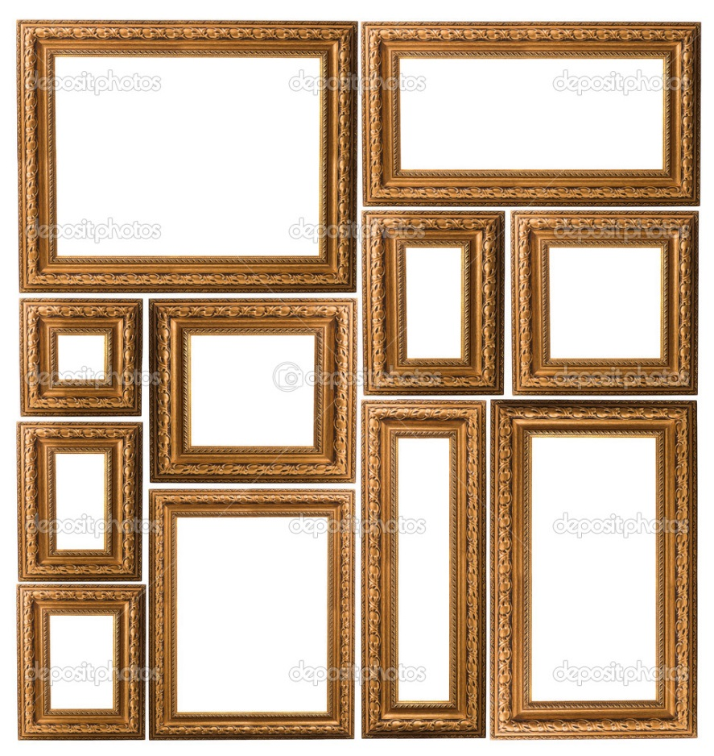

The Invention of Wings

http://tinyurl.com/nwycdmb

Final Product:
- Create either a digital story (with writing and/or narration), or a video (with narration), or a photo essay.
- Include a written reflection that discusses the process, your inspiration, your choices, and your final thoughts on your accomplishment.
- Photos & video must be original from a family “album” or new photos you take for this project.

Due Date: ______________________
Building Background:
- Read: “I Am Writing Blindly”, Roger Rosenblatt
- Read: Reader’s Digest article
- View: “Indian Boy Lost and Found” https://www.youtube.com/watch?v=hW2JFfsisHA
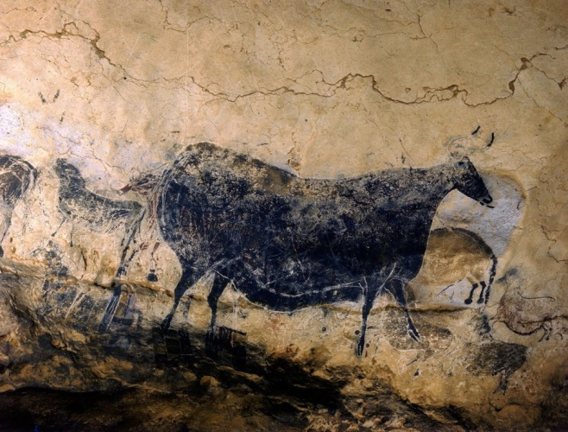
- View: “Life at Lascaux: The First Colour Photos from Another World”

http://tinyurl.com/lsrzzkk

- Respond (summative assessment)

Why do we “write”?

Explore this idea by considering all that you have worked with and with your own experience.

Why do we “write”?
- Use this organizer to keep track of the significant idea developed in each selection.
“I Am Writing Blindly”

Why do we “write”?

“Life at Lascaux”
“Indian Boy Lost and Found”

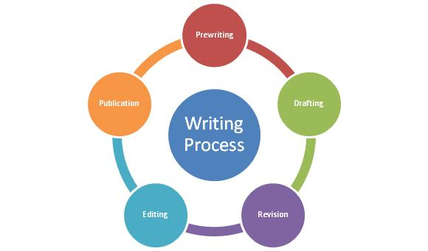
The Process

http://tinyurl.com/msuvobw

- Prewriting: Initial Thinking and Planning

  - Brainstorm: Consider all possibilities to start with.
    - Make a list of the first things that come to mind
      - People, places, memories, activities, books, travel, sports (anything and everything that has been a part of your life)

The big idea you ultimately create may be arrived at in more than one way:
- You have clear direction right from the start.

- You arrive at a final destination through the process and do not see clearly until closer to the end.
- Drafting:

  - Decisions:
    - Format?
    - Culling the list: what will stay? What will go?
    - What pictures need to be found or taken?
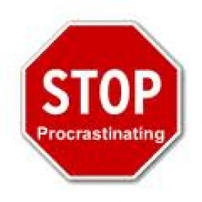
    - Begin writing and creating
      - Plan in whatever way makes sense
        - Outline, notes, charts…

