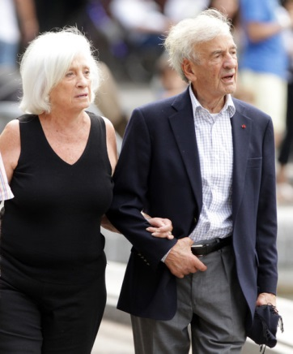
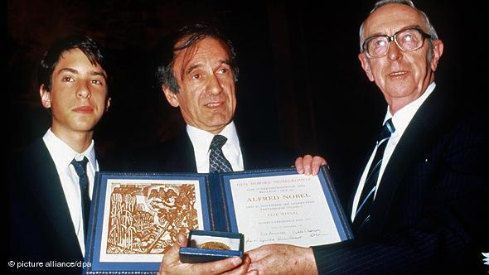
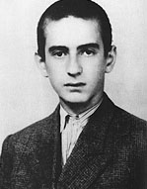
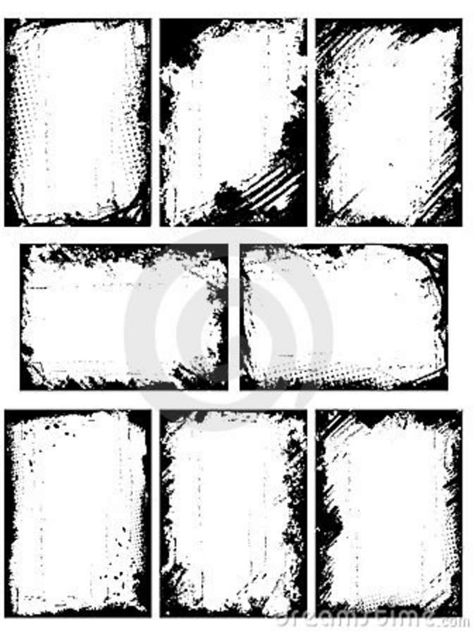

Nobel Peace Prize: 1986

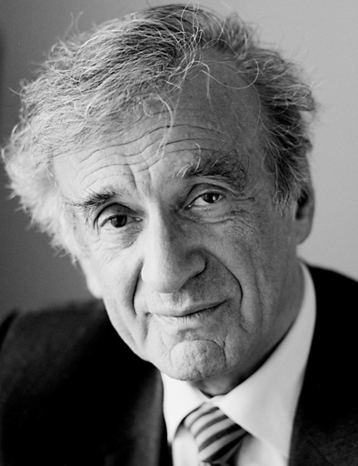
Night
A Memoir of the Holocaust

Elie Wiesel

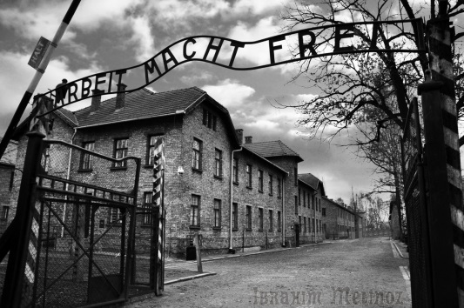
“Human suffering anywhere concerns men and women everywhere.”
― Elie Wiesel, Night
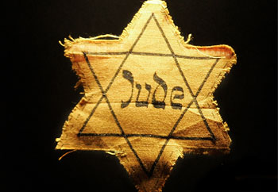

Auschwitz:
Work makes one free

Learning Goals:

Learning Goals | Activities
- Explore ideas  - Build background knowledge  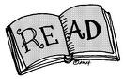  - Read to comprehend and respond  - Manage information  - Create a response:  - Personal  - Creative  - Build community | - Anticipation Guide  - Daily responding  - Background research  - Class PowerPoint  - Research  - Use sticky notes while reading  - Prepare materials for group discussions  - Formal personal response  - Found poem  - Polish one selection from  daily responding  - Literature circles

Night: Anticipation Guide

Directions: Rate each statement according to the Strongly Agree/Strongly Disagree continuum and explain your choice on a separate piece of paper. Then, in your group, discuss each statement. You must reach consensus on your rating. We will then gather as a class to do the same.

- In war, it is acceptable to do whatever is necessary to win.

STRONGLY DISAGREE DISAGREE DEPENDS AGREE STRONGLY AGREE

- All people are created equal.

STRONGLY DISAGREE DISAGREE DEPENDS AGREE STRONGLY AGREE

- People will do whatever is necessary to achieve their goals.

STRONGLY DISAGREE DISAGREE DEPENDS AGREE STRONGLY AGREE

- We are responsible for what happens to us as individuals.

STRONGLY DISAGREE DISAGREE DEPENDS AGREE STRONGLY AGREE

- We need to be concerned about what is happening in other parts of the world.

STRONGLY DISAGREE DISAGREE DEPENDS AGREE STRONGLY AGREE

- It is important to learn from the past.

STRONGLY DISGREE DISAGREE DEPENDS AGREE STRONGLY AGREE

- If necessary, it is acceptable for a government to restrict the freedom of a group of people.

STRONGLY DISAGREE DISAGREE DEPENDS AGREE STRONGLY AGREE

- If injustice occurs, it is important to fight against it.

STRONGLY DSIAGREE DISAGREE DEPENDS AGREE STRONGLY AGREE

Buliding Background:
- What do you already know about the Holocaust, World War II, the Final Solution, concentration and death camps?
Assignment: Class created PowerPoint Presentation
- I will divide you into groups. Each group will be responsible for one aspect of the background information.
- We will create a single class presentation using GoogleDocs.
Topics:
- Elie Wiesel biography
- Concentration Camps and death camps
- The Holocaust (significant events, from 1930s onward)
- Hitler and the Nazis
- Holocaust Memorials
___________________________________________________________________
Reading:
Sections:
- Pages 3-28
- Pages 29-65
- Pages 66-115
To Do:
- Use sticky notes to track your thinking.
- For each section, note the following:
  - Significant events
  - Significant quotes
  - Significant questions: I wonder…
Section 1: pages 3-28 (keep track of page numbers!)
Significant events

Significant quotes

I wonder…

Section 2: pages 29-65
Significant events

Significant quotes

I wonder…

Section 3: pages 66-115
Significant events

Significant quotes

I wonder…

Night, Elie Wiesel
Follow-up

- Episodic Notes: Identify the six most significant events or moments in the book.

- Quotes: Identify and explain the significance of the five most important passages in the book. Use a double entry diary format.

- Questions: Develop five significant, thoughtful questions that you have as a result of reading Night. Share with the class as a way to provoke thought and conversation.

- Personal Response: Write a personal response to Night.

- Part A:Retell A summary of the memoir that captures the heart of it. What is the memoir really about?

- Part B:Relate What is your reaction/response to the memoir?
  - What connections can you make (to yourself, to other texts, to the world today?)

- Part C: Reflect
  - How is this memoir still relevant?
  - What is important about the book, subject?

- Found Poem: Create a found poem. Find a particular passage from Night that you can turn into a poem.

  - Choose a passage, theme, or character from Night.

  - Create a found poem.

  - Include a visual element that enhances/supports the poem.

    - Use a photo essay format.
    - An example will be shown.

  - Write a detailed evaluation of the choices you have made (typed on a separate sheet)
    - What inspired your choices?
    - What, specifically, did you do with the poem (font, bold, colour, spacing, title,…)?
    - What would you do differently if you did this again?

Responding
- The purpose of this activity is to allow you an opportunity to think about and explore ideas related to the study of Night.
- At the beginning of class, you will be given approximately 10 minutes to respond to the prompt.
  - Write
  - Draw
  - Create mind map
  - ?
- At the end of the unit, you will be asked to participate in a discussion forum.

The significance of memory and/or remembering.

_______________________________________________________________________________________________________________________________________________________________________________________________________________________________________________________________________________________________________________________________________________________________________________________________________________________________________________________________________________________________________________________________________________________________________________________________________________________________________________________________________________________________________________________________________________________________________________________________________________________________________________________________________________________________________________________________________________________________________________________________________________________________________________________________________________________________________________________________________________________________________________________________________________________________________________________________________________________________________________________________________________________________________________________________________________________________________________________________________________________________________________________________________________________________________________________________________________________________________________________________________________________________________________________________________________________________________________________________________________________________________________________________________________________________________________________________________________________________________________________________________________________________________________________________________________________________________________________________________________________________________________________________________________________________________________________________________________________________________________________________________________________________________________________________________________________________________________________________________________________________________________________________________________________________________________________________________________________________________________________________________________________________________________________________________________________________________________________________________________________________________________________________________________________________________________________________________________________________________________________________________________________________________________________________________________________________________________________________________________________________________________________________________
Justice and revenge.

______________________________________________________________________________________________________________________________________________________________________________________________________________________________________________________________________________________________________________________________________________________________________________________________________________________________________________________________________________________________________________________________________________________________________________________________________________________________________________________________________________________________________________________________________________________________________________________________________________________________________________________________________________________________________________________________________________________________________________________________________________________________________________________________________________________________________________________________________________________________________________________________________________________________________________________________________________________________________________________________________________________________________________________________________________________________________________________________________________________________________________________________________________________________________________________________________________________________________________________________________________________________________________________________________________________________________________________________________________________________________________________________________________________________________________________________________________________________________________________________________________________________________________________________________________________________________________________________________________________________________________________________________________________________________________________________________________________________________________________________________________________________________________________________________________________________________________________________________________________________________________________________________________________________________________________________________________________________________________________________________________________________________________________________________________________________________________________________________________________________________________________________________________________________________________________________________________________________________________________________________________________________________________________________________________________________________________________________________
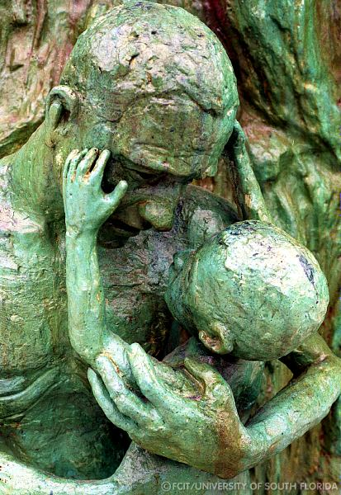

A Sculpture of Love and Anguish
This is a photograph of one small part of a much larger memorial in Miami.
http://fcit.usf.edu/holocaust/GALL34R/MIAMI61.HTM

http://fcit.usf.edu/holocaust/GALL34R/MIAMI61.HTM

________________________________________________________________________________________________________________________________________________________________________________________________________________________________________________________________________________________________________________________________________________________________________________________________________________________________________________________________________________________________________________________________________________________________________________________________________________________________________________________________________________________________________________________________________________________________________________________________________________________________________________________________________________________________________________________________________________________________________________________________________________________________________________________________________________________________________________________________________________________________________________________________________________________________________________________________________________________________________________________________________________________________________________________________________________________________________________________________________________________________________________________________________________________________________________________________________________________________________________________________________________________________________________________________________________________________________________________________________________________________________________________________________________________________________________________________________________________________________________________________________________________________________________________________________________________________________________________________________________________________________________________________________________________________
Hope.

__________________________________________________________________________________________________________________________________________________________________________________________________________________________________________________________________________________________________________________________________________________________________________________________________________________________________________________________________________________________________________________________________________________________________________________________________________________________________________________________________________________________________________________________________________________________________________________________________________________________________________________________________________________________________________________________________________________________________________________________________________________________________________________________________________________________________________________________________________________________________________________________________________________________________________________________________________________________________________________________________________________________________________________________________________________________________________________________________________________________________________________________________________________________________________________________________________________________________________________________________________________________________________________________________________________________________________________________________________________________________________________________________________________________________________________________________________________________________________________________________________________________________________________________________________________________________________________________________________________________________________________________________________________________________________________________________________________________________________________________________________________________________________________________________________________________________________________________________________________________________________________________________________________________________________________________________________________________________________________________________________________________________________________________________________________________________________________________________________________________________________________________________________________________________________________________________________________________________________________________________________________________________________________________________________________________________________________________________________________________________________________________________________
Self-Reflection
After reading and working with Night…

I think…

I feel…

I wonder…

