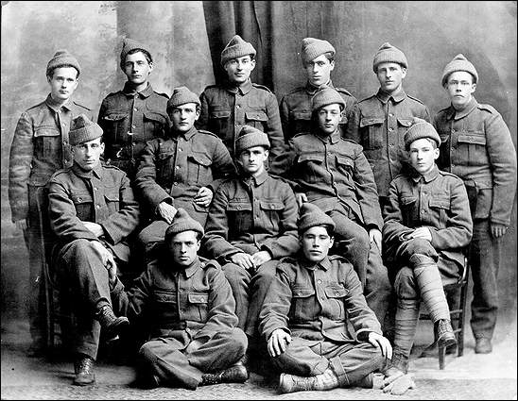
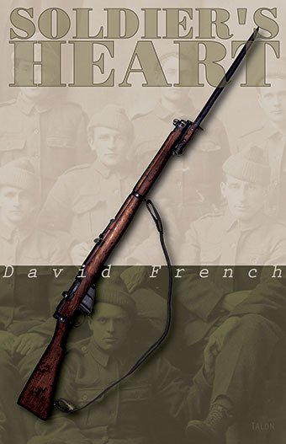

Newfoundland Regiment Section 2, Platoon 1

July 1, 1916
The Battle of the Somme
A Newfoundland Regiment
The wounding of a soul.
_________________________________
1924
The platform of a train station
A father and a son
How can a “soldier’s heart” be healed?

Building Background
- Why is July 1st important to Newfoundlanders? (It’s not about Canada Day!)

- Watch the following videos:
  - For King and Empire: The Battle of the Somme 1916 Slaughter and Sacrifice

  - The Battle of the Somme

- Read the attached article “Soldier’s Heart”
What is soldier’s heart?

Reflection:
The soldier above all others prays for peace, for it is the soldier who must suffer and bear the deepest wounds and scars of war.
Douglas MacArthur

http://www.brainyquote.com/quotes/keywords/soldier.html

___________________________________________________________________________________________________________________________________________________________________________________________________________________________________________________________________________________________________________________________________________________________________________________________________________________________________________________________________________________________________________________________________________________________________________________________________________________________________________________________________________________________________________________________________________________________________________________________________________________________________________________________________________________________________________________________________________________________________________________________________________________________________________________________________________________________________________________________________________________________________________________________________________________________________________________________________________________________________________________________________________________________________________________________________________________________________________________________________________________________________________________________________________________________________________________________________________________________________________________________________________________________________________________________________________________________________________________________________________________________________________________________________________________________________________________________________________________________________________________________________________________________________________________________________________________________________________________________________________________________________________________________________________________________________________________________________________________________________________________________________________________________________________________________________________________________________________________________________________________________________________________________________________________________________________________________________________________________________________________________________________________________________________________________________________________________________________________________________________________________________________________________________________________________________________________________________________________________________________________________________________________________________________________________________________________________________________________________________________________________________________________________________________________________________________________________________________________________________________________________________________________________________________________________________________________________________________________________________________________________________________________________________________________________________________________________________________________________________________________________________________________________________________________________________________________________________________________________________________________________________________________________________________________________________________________________________________________________________________
Reading and Responding:
- Read through the play once to get a sense of what is going on.

THEN READ AGAIN

- Create your own chart or graphic organizer or mind map that encompasses the following:

- The characters
    - Who are they?
    - Relationships?
    - Conflicts and resolutions?
    - Characteristics?
    - Connection to theme?

- Structure & Style of the play
    - Setting
    - Time frame of the play itself
    - Title
    - Costume
    - Lighting
    - Music
    - Symbolism

- Theme

Personal Response

What idea(s) and impression(s) does Soldier’s Heart suggest?

In your writing, you should

- select a prose form that is appropriate to the ideas you wish to express
and that will enable you to effectively communicate to the reader

- discuss ideas and impressions that are meaningful to you

PTSD

Soldier’s Heart?
By Ron CappsSept. 02, 2011Add a Comment
My colleague Mark Thomspon has already highlighted the Miller-McCune piece about Post-Traumatic Stress Disorder sometimes being thought of as an injury to the warrior’s soul. But I wanted to comment on this one as well. As I have noted here several times I was treated for PTSD both in theater and stateside. I’ve spent a lot of time thinking, talking and writing about my personal struggles and those of the hundreds of thousands of other survivors.
In brief, the Miller-McCune article says that some PTSD is caused by damage to a warrior’s soul. This might happen because of some action or lack of action during the time in combat. I suspect this will cause some eye rolling, especially among the “PTSD is weakness” crowd. But that group is unlikely to be converted to believe the fact that PTSD is an injury with both physical and emotional symptoms.
But what’s all this stuff about injury to the soul? To avoid getting all metaphysical, it might help to think of morality in wartime as operating within both the laws of war and the rules of honor, integrity and morality that are ingrained in each of us as a member of society and within our specific culture. If a soldier were to commit an atrocity, that would break both the legal and the moral or spiritual rules. International tribunals and courts-martial help to sort out the former, but what about the latter? And what about actions that don’t rise to the level of atrocities?
Actions an individual soldier commits, or in some cases actions a soldier might not take, seem to be at the core of this phenomenon. Some of us have been taught that killing is never acceptable. Much of this type of thought springs from a theological fount, and many have sought status as a conscientious objector to avoid direct combat roles during wartime. But others, including those who might not share a strict interpretation of the sixth commandment, might feel an extreme sense of guilt at having killed in wartime. This is the where we start to get into the realm of moral injury.
We often think of PTSD as the result of some life-threatening event. But it seems the wound to the soul might be something else. Jonathan Shay, author of the much acclaimed Achilles in Vietnam, notes that soldiers often suffer from PTSD following what they view as a betrayal by senior leaders. This goes right to the sense of honor and integrity that serves as the core of military values soldiers learn from their first days of initial entry training. Words like morality and ethics and moral order are often used among philosophers and ethicists in their studies and academic papers. But words like integrity, trust and honor have tangible meaning among warriors.
I was in Zaire and Uganda in 1996 when the Banyamulenge and the Rwandans were cleaning out Mobutu’s army and the remnants of the Interahamwe in the east of the country. Half a million refugees in camps along the Rwandan border disappeared into the forest. An international military task force sat in Kampala, ready to intervene to protect the refugees, but, incredibly, the international community struggled to find them. A few days before Christmas, I received images filmed by a missionary pilot flying in the interior that pinned down the location of over 100,000 civilians. I presented the video to the American general commanding the task force but he did nothing more than instruct me to pass the information on to the UN.
Shay’s writings conclude that when soldiers sense that their leaders have betrayed the core values, especially when there is much at stake – life and death, for example – there follows a soul-crushing sense that there is no longer a clear right and wrong. The world no longer makes sense in any moral way. A commander who betrays these values “inflicts manifold injuries upon his men.”
Many, many soldiers suffer survivor’s guilt. We ran a story here a few weeks ago about a soldier who was given a day off by his squad leader and then the squad leader and the entire squad were killed on a patrol. Do you think that would keep you up at night?
There are also the things left undone or unfinished. When I was in Kosovo my team went into Senik, a village that had been attacked by the Serbs and almost certainly faced subsequent attacks. A woman tried to hand me her infant hoping I would carry the child out to safety. I refused because I knew the Serbs would throw me out of the province for violating the neutrality of my observer status. I don’t know what happened to her or her child in the subsequent attacks on that village, but think about it a lot.
A few months later I watched from a hilltop as Serbian police attacked the village of Račak. I was sitting on the hill watching because the Serbian police had blocked the road and I didn’t want to create an international incident. The next morning I came back and found 45 dead civilians including women, children and old men.
I’ll never get those images out of my head. Is this an injury to my soul? Maybe. I know it is an injury to my mind. And doctors say it could be the cause of an injury to my brain as well. In this study published in 2010, scientists note that PTSD changes the shape and size of the hippocampus, the part of the brain most directly involved in storing and re-calling specific memories.
I had my share of incidents that put me in fear of death over five different conflicts in a dozen years. Things like a Serb thug pressing his pistol into my temple and screaming he was going to kill me and then rape my female translator; and teenaged Afghan militia fighters holding me hostage in the middle of the night, laughing while they poked and prodded me with their Kalashnikovs; and rocket fire in Iraq. I’m sure, and so are my psychiatrists, that these factor in to my PTSD. But the things that bother me most, the things that haunt me at night, are the things I left undone or the things I couldn’t or didn’t do.
In the Civil War, PTSD was called Soldier’s Heart. Doctors used to describe the symptoms as nostalgia – an inability to focus on the present due to remembrances of things past. In World War I, soldiers with blood and bone wounds were authorized a wound stripe on their uniform and a pension. Today, blood and bone wounds warrant a Purple Heart medal. PTSD doesn’t rate a Purple Heart, and I am not advocating for that. But I think it’s important to remember that not all wounds are visible; that this is a combat wound and that, because it deals with the mind, we know precious little about how it happens of how to properly treat it. A wound to the soul? Absolutely.
http://nation.time.com/2011/09/02/soldiers-heart/#ixzz2jzAS2Jpu

