What can maps tell us about our world?

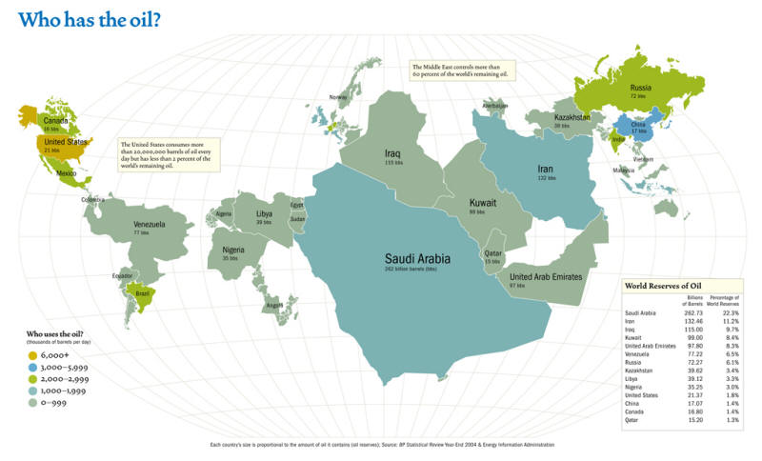

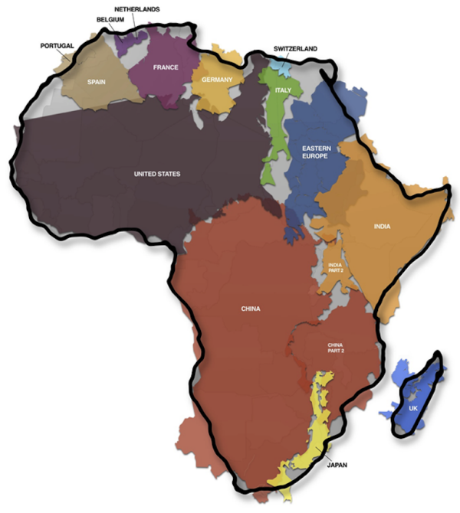
The true size of Africa

Life Expectancy
- Visit the following website to see a better picture
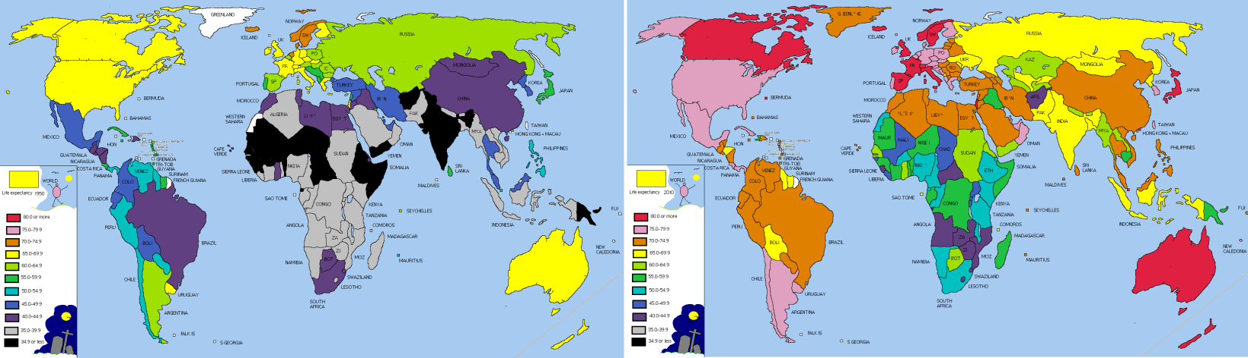
- http://www.fooddeserts.org/images/LifeExpectancy.bmp

Literacy Rates
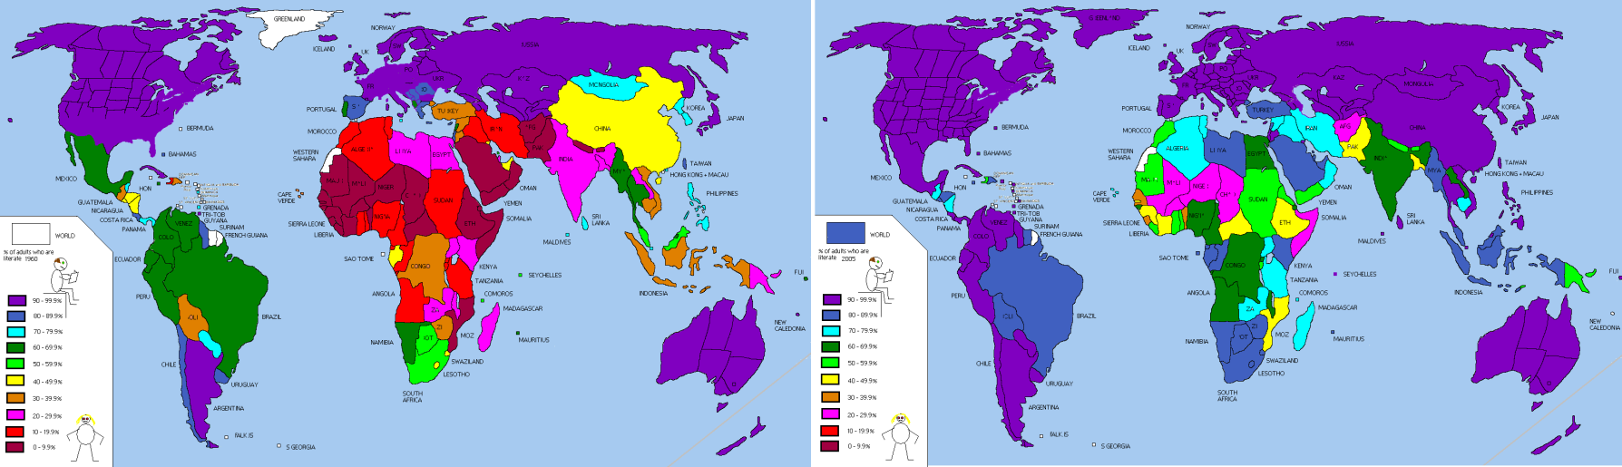
- http://www.fooddeserts.org/images/LiteracyRate19602005.bmp

Urbanization
http://www.fooddeserts.org/images/Urbanisation.bmp
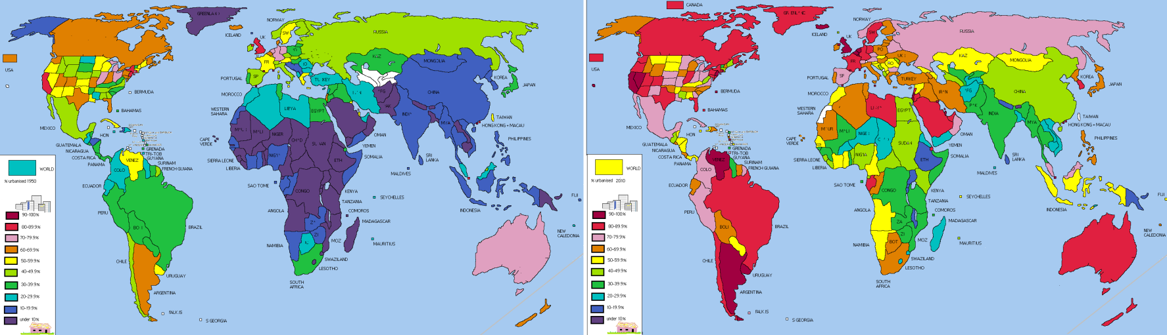

TV Broadcasting
http://www.fooddeserts.org/images/StartofTV.bmp
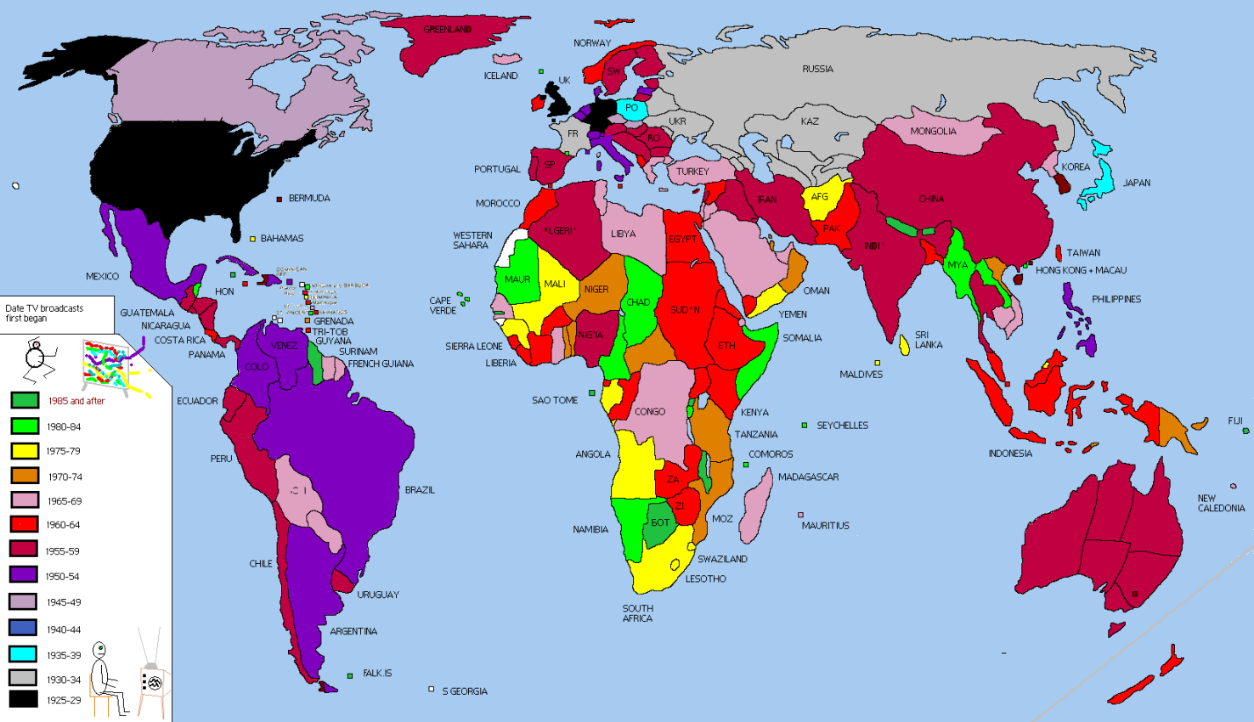

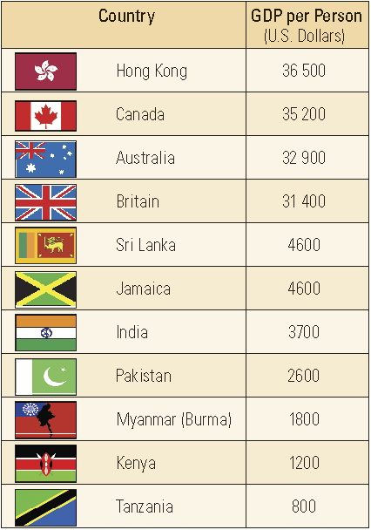
GDP
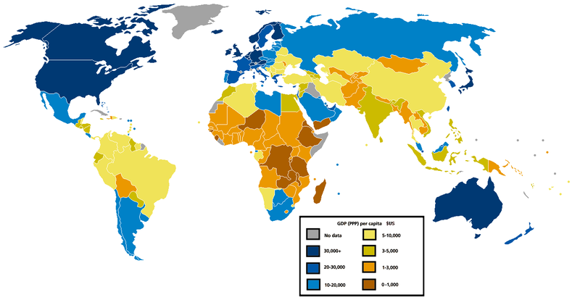

http://commons.wikimedia.org/wiki/File:Gdp_per_capita_ppp_world_map_2005.PNG

