Free the Children
Craig Kielberger
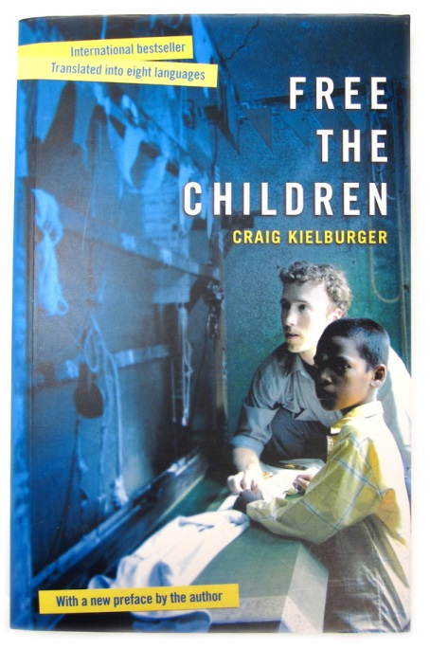

What is the power of an individual to make change?

Assignment:
- Complete one entry for each reading section.

- Find a passage from the book.
  - Write this in the left column.
  - In the right column, write your thinking, response, interpretation…

Double Entry Diary

Name: _____________________
Due Date: __________________

Reading Sections:
- Pages 8-47
- Pages 48-105
- Pages 106-137
- Pages 138-188
- Pages 189-243

Entry One: _____________________________________
Page #_______
Quote | Response  ____________________________________________________________________________________________________________________________________________________________________________________________________________________________________________________________________________________________________________________________________________________________________________________________________________________________________________________________________________________________________________________________________________________________________________________________________________________________________________________________________________________________________________________________________________________________________________________________________________________________________________________________________________________________________________________________________________________________________________________________________________________________________________________________________________________________________________________________________________________________________________________________________________________________________________________________________________________________________________________________________________________________________________________________________________________________________________________________________________________
Entry Two: _____________________________________
Page #_______
Quote | Response  ____________________________________________________________________________________________________________________________________________________________________________________________________________________________________________________________________________________________________________________________________________________________________________________________________________________________________________________________________________________________________________________________________________________________________________________________________________________________________________________________________________________________________________________________________________________________________________________________________________________________________________________________________________________________________________________________________________________________________________________________________________________________________________________________________________________________________________________________________________________________________________________________________________________________________________________________________________________________________________________________________________________________________________________________________________________________________________________________________________________
Entry Three: _____________________________________
Page #_______
Quote | Response  ____________________________________________________________________________________________________________________________________________________________________________________________________________________________________________________________________________________________________________________________________________________________________________________________________________________________________________________________________________________________________________________________________________________________________________________________________________________________________________________________________________________________________________________________________________________________________________________________________________________________________________________________________________________________________________________________________________________________________________________________________________________________________________________________________________________________________________________________________________________________________________________________________________________________________________________________________________________________________________________________________________________________________________________________________________________________________________________________________________________
Entry Four: _____________________________________
Page #_______
Quote | Response  ____________________________________________________________________________________________________________________________________________________________________________________________________________________________________________________________________________________________________________________________________________________________________________________________________________________________________________________________________________________________________________________________________________________________________________________________________________________________________________________________________________________________________________________________________________________________________________________________________________________________________________________________________________________________________________________________________________________________________________________________________________________________________________________________________________________________________________________________________________________________________________________________________________________________________________________________________________________________________________________________________________________________________________________________________________________________________________________________________________________

Five: _____________________________________
Page #_______
Quote | Response  ____________________________________________________________________________________________________________________________________________________________________________________________________________________________________________________________________________________________________________________________________________________________________________________________________________________________________________________________________________________________________________________________________________________________________________________________________________________________________________________________________________________________________________________________________________________________________________________________________________________________________________________________________________________________________________________________________________________________________________________________________________________________________________________________________________________________________________________________________________________________________________________________________________________________________________________________________________________________________________________________________________________________________________________________________________________________________________________________________________________

Mark the various stops Craig makes on his journey.

Using GoogleEarth, visit the cities Craig talks about. Use the space on the following page for notes and thoughts.

Notes and Thoughts
_____________________________________________________________________________________________________________________________________________________________________________________________________________________________________________________________________________________________________________________________________________________________________________________________________________________________________________________________________________________________________________________________________________________________________________________________________________________________________________________________________________________________________________________________________________________________________________________________________________________________________________________________________________________________________________________________________________________________________________________________________________________________________________________________________________________________________________________________________________________________________________________________________________________________________________________________________________________________________________________________________________________________________________________________________________________________________________________________________________________________________________________________________________________________________________________________________________________________________________________________________________________________________________________________________________________________________________________________________________________________________________________________________________________________________________________________________________________________________________________________________________________________________________________________________________________________________________________________________________________________
The Power of an Individual?
A waterfall begins from only one drop of water... Look what comes from that...

(http://www.imdb.com/title/tt0105159/quotes)

The quote comes from the movie The Power of One, a story of South Africa during Apartheid.

- Consider this quote as we work through the following pieces.
- When we are done, write a response to this quote.

We are going to look at two more individuals who have committed to changing the way things are done.
- What have they done?
- Why have they done it?
- What has been the result?

Case Study #1: Malala Yousafzai
- Access the following website to read the story of Malala
http://zenpencils.com/comic/104-malala-yousafzai-i-have-the-right/

- Complete some further research.
  - Where is she now?
  - What project is she working on?
Response:
____________________________________________________________________________________________________________________________________________________________________________________________________________________________________________________________________________________________________________________________________________________________________________________________________________________________________________________________________________________________________________________________________________________________________________________________________________________________________________________________________________________________________________________________________________________________________________________________________________________________________________________________________________________________________________________________________________________________________________________________________________________________________________________________________________________________________________________________________________________________________________________________________________________________________________________________________________________________________________________________________________________________________________________________________________________________________________________________________________________________________________________________________________________________________________________________________________________________________________________________________________________________________________________________________________________________________________________________________________________________________________________________________________________________________________________________________________________________________________________________________________________________________________________________________________________________________________________________________________________________________________________________________________________________________________________________________________________________________________________________________________________________________________________________________________________________________________________________________________________________________________
Case Study # 2: Barb Stegemann, 7 Virtues perfume and book
- Visit website http://www.the7virtues.com/canada.index.html#

- View Dragon’s Den excerpt
http://www.youtube.com/watch?v=S8px80B59tM (original)
http://www.youtube.com/watch?v=P-3xMD9wRiE (update)
Response:
_____________________________________________________________________________________________________________________________________________________________________________________________________________________________________________________________________________________________________________________________________________________________________________________________________________________________________________________________________________________________________________________________________________________________________________________________________________________________________________________________________________________________________________________________________________________________________________________________________________________________________________________________________________________________________________________________________________________________________________________________________________________________________________________________________________________________________________________________________________________________________________________________________________________________________________________________________________________________________________________________________________________________________________________________________________________________________________________________________________________________________________________________________________________________________________________________________

