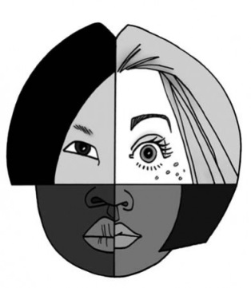
Ethnic and Cultural Diversity in Canada
Changing immigration and ethnic diversity in Canadian society

Changing Canadian Immigration Patterns
One of Canada’s defining characteristics, without question, is that it is a nation of immigrants. That said, it is important to note that Canada’s ethnic makeup has altered significantly over time due to changing immigration patterns. During its colonial period, the region was constituted by three main ethnic groups. Prior to any European settlement, what we know today as Canada was populated by Aboriginal or First Nations peoples. This ethnic group was far from homogeneous; instead it was (and continues to be) constituted by a wide array of different groups with their own social, economic, and political practices.
With colonialization and settlement, two key European ethnic groups joined the Aboriginal peoples in Canada: the British and the French. Initially, the British settled along the eastern coastline in what is today the Atlantic provinces and Ontario. The French settled primarily in what is today known as Quebec and Nova Scotia. While the British and French were both European, they were nevertheless culturally distinct. Not only did they have different languages, they also practiced different religions (the French were Catholic, while the British were protestant), political and legal traditions. Eventually, the British conquered the former French colonies, absorbing them into their North American territories. Nevertheless, the French culture has survived in modern Canadian history.
The early presence of these three main ethnic groups is significant in that it has given rise to a view of Canada as being constituted by three founding nations ― Aboriginal peoples, the British, and the French (the addition of Aboriginals to this founding nation perspective is much more recent). This common view of Canada is significant, not only because of its influence on the nation’s political and social institutions, but also because it often stands in conflict to newer conceptions of the country ― in particular, the notion of Canada as a multicultural nation. Whereas the founding nation view suggests that Aboriginal peoples, the French and the British are to be recognized as special cultures, the multicultural view holds that Canada is composed of a wide variety of equally significant cultures.
Following Aboriginal peoples, the French and the British, people from many other countries began to immigrate to Canada. By the time of Confederation in 1867, a large German population had arrived. Immigration to Canada particularly surged during the late 1800s and early 1900s, with the opening of the Canadian west and the construction of the transnational railway. This immigration wave included large contingents from Britain, the United States, Scandinavia, and eastern Europe. While immigration primarily reflected the ethnicity of the United States and Europe, there were also settlements by other groups, of non-European descent. In British Columbia, for example, thousands of Chinese workers were brought in to help with the construction of the railroad. Nova Scotia and Ontario also saw an influx of Afro-American immigrants, escaping slavery in the United States.
Over the course of the twentieth century, Canada experienced a radical shift in its immigration patterns. Between 1900 and 1965, Europe (in particular, Britain) was the primary source of immigrants to Canada. By the end of the century, however, Asia represented the largest region of origin for new Canadians. Other areas, including Africa, the Middle East, and South and Central America have also become important sources of contemporary immigration for Canada. This shift has been caused, in large part, to changes in Canada’s immigration policy. The country’s early immigration policy focused on bringing white, skilled peoples from Europe and the United States. Beginning in the 1960s, however, policy was relaxed to allow for better opportunities for immigrants from other areas.
Sources of Immigration to Canada (percent)
 | Britain | Europe | Asia
1957 | 38.6 | 52.6 | 1.3
1967 | 28.0 | 43.8 | 9.3
1977 | 15.7 | 19.8 | 21.0
1987 | 5.6 | 19.1 | 44.3
1997 | 2.2 | 15.7 | 54.2
2007 | - | 16.5* | 47.6
Sources: Dyke, 2000; Citizenship and Immigration Canada, 2008.
* This total includes both Britain and Europe.

Contemporary Canadian Ethno-cultural Diversity
These changing patterns in immigration have resulted in Canada becoming a highly diverse nation, in terms of both ethnicity and culture. While the largest ethnic groups were predominantly of European descent, and English or French in particular, the Canadian population has increasingly become constituted by other ethnicities, most notably Chinese and East Indian. It is important to note, however, that this diversity is not uniform across the country. The populations of Quebec, Ontario, Alberta, and British Columbia contain greater diversity than other provinces. Canada’s large metropolitan areas, in particular Toronto, Montreal and Vancouver, tend to be more diverse than its rural areas.

Top 15 Ethnic Origins of Canadians (2006)
Ethnic Origin | Total Responses* | Percent of Population
English | 6,570,015 | 20.2
French | 4,941,210 | 15.3
Scottish | 4,719,850 | 14.4
Irish | 4,354,155 | 13.5
German | 3,179,425 | 9.8
Italian | 1,445,335 | 4.3
Chinese | 1,346,510 | 4.0
North American Indian | 1,253,615 | 4.0
Ukrainian | 1,209,085 | 3.7
Dutch | 1,035,965 | 3.1
Polish | 984,565 | 3.0
East Indian | 962,665 | 2.9
Russian | 500,600 | 1.5
Welsh | 440,965 | 1.3
Filipino | 436,190 | 1.3
Sources: Statistics Canada, 2008
* Respondents were permitted to provide multiple responses to the question of their ethnic origin, as well as decline to respond.
This greater diversity in terms of country of origin has, in turn, led to other changes in the Canadian population. Of particular importance are increases in the nation’s visible minorities (segments of the population other than Caucasian). Again, this trend is particularly evident in Canada’s major metropolitan areas. In Toronto and Vancouver, for example, visible minorities constitute almost half the total population.
Visible Minorities in Canada and in main Metropolitan Areas (2006)
Area | Percent of Population
Canada | 16.2
Toronto | 42.9
Vancouver | 41.7
Montreal | 16.5
Source: Brooks, 2009.
Not only has this diversity altered Canada’s racial makeup, it has also resulted in new cultural practices and traditions in the Canadian population. This includes greater diversity in the context of key cultural institutions, such as language, the family and religion, as well as attitudes towards societal issues, such as gender, sexuality, civility, and authority. As such, Canada is not a uniform nation, in that it is not solely grounded in the values and practices of European, Christian culture. It is, instead, a highly pluralistic society, whose population practices a diverse set of ethnic and religious traditions.
http://mapleleafweb.com/features/multiculturalism-policy-canada

Statistics Canada today releases detailed analyses of data from the 2006 Census on ethnic origin, visible minorities, place of work and mode of transportation.
These analyses are now available in two online documents: Canada's Ethnocultural Mosaic, 2006 Census, and Commuting Patterns and Places of Work of Canadians, 2006 Census.

More than 200 different ethnic origins reported
Each wave of immigration to Canada has increased the ethnocultural diversity of the nation's population. In fact, more than 200 different ethnic origins were reported in the 2006 Census. In contrast, just about 25 different ethnic groups were recorded in Canada in the 1901 Census.
(Ethnic origin refers to the ethnic or cultural origins of the respondent's ancestors. An ancestor is someone from whom a person is descended and is usually more distant than a grandparent.)
In 1901, people who reported Aboriginal ancestries, and British and French origins, comprised the largest share of the population.
The list of ethnic ancestries in 2006 includes cultural groups associated with Canada's Aboriginal people (North American Indian, Métis and Inuit), the European groups that first settled in Canada, such as the English, French, Scottish and Irish. It also includes origins reflecting immigrants who came to Canada over the past century, such as German, Italian, Chinese, Ukrainian, Dutch, Polish, East Indian and so on.
Among newer groups reported in 2006 were Montserratan from the Caribbean and Chadian, Gabonese, Gambian and Zambian from Africa.
By 2006, 11 ethnic origins had passed the 1-million population mark. The largest group enumerated by the census consisted of just over 10 million people who reported Canadian as their ethnic ancestry, either alone (5.7 million) or with other origins (4.3 million).
The other most frequently reported origins were English, French, Scottish, Irish, German, Italian, Chinese, North American Indian, Ukrainian and Dutch. These ancestries were either reported alone or in combination with other origins, reflecting the increasing diversity of the population.

Visible minority population surpasses 5-million mark
In 2006, the census enumerated an estimated 5,068,100 individuals who belonged to the visible minority population. They made up 16.2% of the total population in Canada.
(The census collects information on this population to meet federal employment equity legislation requirements under the Employment Equity Act. According to the Act, visible minorities are defined as "persons, other than Aboriginal persons, who are non-Caucasian in race or non-white in colour.")
The visible minority population has grown steadily over the last 25 years. In 1981, when data for the employment equity-designated groups were first derived, the estimated 1.1 million visible minorities represented 4.7% of Canada's total population.
In 1991, 2.5 million people were members of the visible minority population, 9.4% of the population. The visible minority population further increased to 3.2 million in 1996, or 11.2% of the total population. By 2001, their numbers had reached an estimated 3,983,800 or 13.4% of the total population.
Between 2001 and 2006, the visible minority population increased at a much faster pace than the total population. Its rate of growth was 27.2%, five times faster than the 5.4% increase for the population as a whole.
The growth of the visible minority population was due largely to the increasing number of recent immigrants (landed immigrants who came to Canada up to five years prior to a given census year) who were from non-European countries. In 1981, 68.5% of all recent immigrants to Canada were born in regions other than Europe, and by 1991, this proportion had grown to 78.3%. The 2006 Census showed that 83.9% of the immigrants who arrived between 2001 and 2006 were born in regions other than Europe.
Consequently, the proportion of newcomers who belonged to a visible minority group also increased. In 1981, 55.5% of the newcomers who arrived in Canada in the late 1970s belonged to a visible minority group. In 1991, slightly over 7 in 10 (71.2%) recent immigrants were members of a visible minority group, and this proportion reached 72.9% in 2001.
Fully three-quarters (75.0%) of the immigrants who arrived between 2001 and 2006 belonged to a visible minority group.
If current immigration trends continue, Canada's visible minority population will continue to grow much more quickly than the non-visible minority population. According to Statistics Canada's population projections, members of visible minority groups could account for roughly one-fifth of the total population by 2017.

South Asians surpass Chinese as the largest visible minority group
The South Asians became Canada's largest visible minority group in 2006, surpassing Chinese for the first time. The populations of both were well over 1 million.
The 2006 Census enumerated an estimated 1,262,900 individuals who identified themselves as South Asian, a growth rate of 37.7% from 917,100 individuals in 2001. They represented one-quarter (24.9%) of all visible minorities, or 4.0% of the total population in Canada.
In contrast, the number of individuals who identified themselves as Chinese increased 18.2% from 1,029,400 in 2001 to 1,216,600 in 2006. Chinese accounted for 24.0% of the visible minority population and 3.9% of the total Canadian population.
The number of those identifying themselves as Black, the third largest visible minority group, rose 18.4% from 662,200 individuals in 2001 to an estimated 783,800. They accounted for 15.5% of the visible minority population and 2.5% of the total population in 2006.
Other visible minority groups included Filipinos, who represented 8.1% of the visible minority population, Latin Americans (6.0%), Arabs (5.2%), Southeast Asians (4.7%), West Asians (3.1%), Koreans (2.8%) and Japanese (1.6%).
(http://www.statcan.gc.ca/daily-quotidien/080402/dq080402a-eng.htm)
Interactive Map
- Visit the following site which has an interactive map that shows where people have migrated from, to Canada.
- World Migration- International Organization for Migration
  - http://www.iom.int/cms/en/sites/iom/home/about-migration/world-migration.html
How does migration affect identity, both collective and individual?

Aboriginal Diversity in Canada
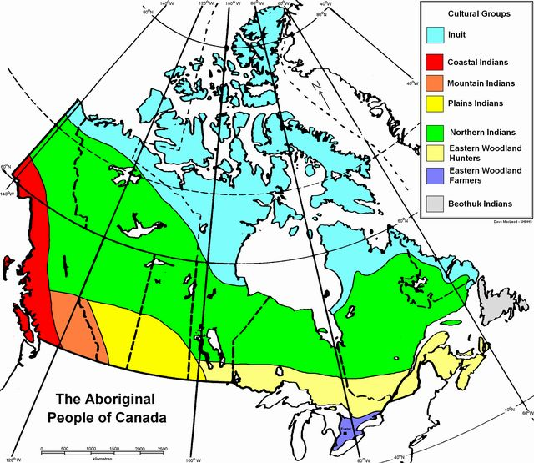

- How many First Nations people live in Canada?

- Define/explain:
  - Aboriginal

  - First Nations

  - Metis

  - Inuit

Who are the First Nations and Inuit
peoples in Canada?
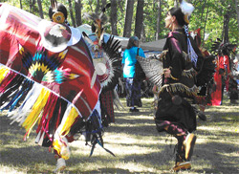
Image distributed under Creative Commons license, courtesy Flickr.
Before European settlers arrived in Canada about 500 years ago, First Nations and Inuit peoples had the country pretty much to themselves. They lived in groups called tribes, with many different ways of life and traditions. Some were nomadic, which means they moved from place to place while hunting and gathering food. Others were farmers who settled down in a particular area. The weather and the type of land where each tribe lived helped to shape their traditions and culture.

Reproduced with permission from the Glenbow Museum website (www.glenbow.org).

- Visit the following website for more detailed information
- www.ecokids.ca
  - Within site, search “First Nations and Inuit”
http://www.ecokids.ca/pub/eco_info/topics/first_nations_inuit/groups.cfm

What do the map and the information suggest about Aboriginal diversity in Canada?
- How does this relate to collective and individual identity?

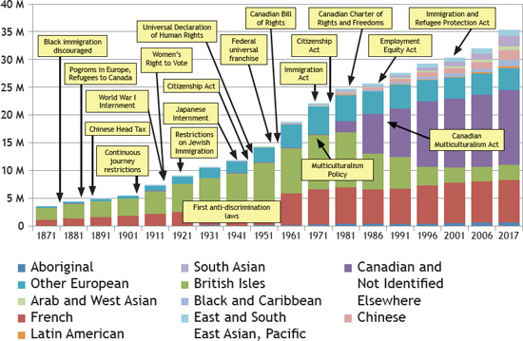
Legislative Changes: How does government policy affect diversity?

How has government policy affected diversity in Canada?
- Use the above chart to help you answer this.

Factors related to Immigration:
- Identify each factor as: social, economic, political
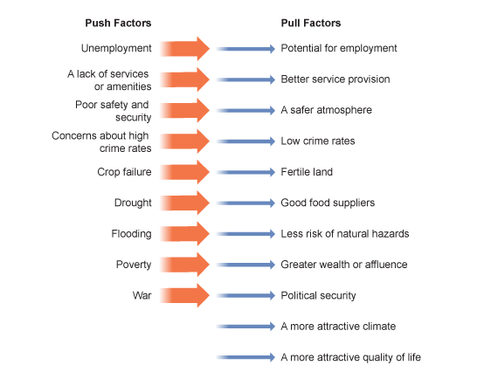

http://www.bbc.co.uk/schools/gcsebitesize/geography/migration/migration_trends_rev2.shtml

