IMPERIALISM IN THE AMERICAS:
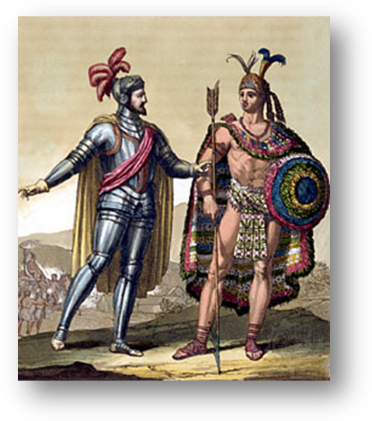
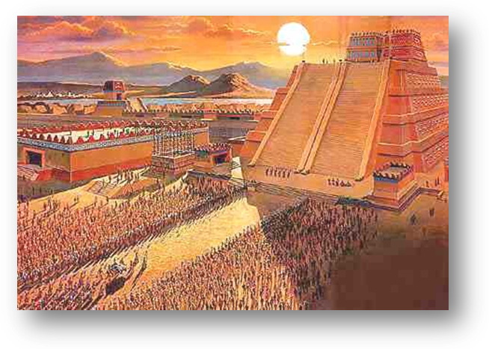
Cortez and the Aztecs
Spanish explorer Hernan Cortes and Aztec leader Moctezuma II - Picture Source: http://www.britannica.com/EBchecked/topic-art/138839/92054/Hernan-Cortes-with-Montezuma-II
The Aztec city of Tenochtitlan- population approx.300,000 citizens. (Located on present day Mexico City)- Picture Source: http://s3.amazonaws.com/readers/2009/10/22/aztecpyramidgathering_1.jpg
Use these websites to gain an understanding:
Main site for information: http://www.carpenoctem.tv/military/cortes.html
Short, additional information: http://education.yahoo.com/reference/encyclopedia/entry/Tenochti
Additional indepth information: http://www.channel4.com/history/microsites/H/history/i-m/lastaztec.html

- In your opinion, what were Cortez’s two most significant motivations for exploring?

- Give evidence to agree or disagree with this statement: Cortez respected and tolerated the Aztec religion.

Cortez was victorious over the Aztec, after fighting and small pox killed numbers- estimated in the “hundreds of thousands.” (http://en.wikipedia.org/wiki/Spanish_conquest_of_the_Aztec_Empire)

- What was the Spanish monarchy’s response to the great many Aztecs killed by fighting and disease?

  - Are you surprised at their response? Why or why not?

- When encountering the Indigenous people of the Americas, how could you describe Spanish opinion towards these people?

  - If Cortez were alive today and discovered the Aztecs in the 21st century, explain, using specific evidence, how their interactions would likely be different.

