Invictus
(Latin for “undefeated” or “unconquered)
Invictus is a biographical film that chronicles the events in South Africa shortly after the end of Apartheid. Nelson Mandela is the newly elected president of South Africa, and needs/wants to find a way to unite the country. Because of the history of Apartheid, the division between black and white is enormous. Rugby (football) is an important sport in South Africa, so Mandela chooses to use the 1995 Rugby World Cup as a way to begin the healing process for South Africa.
______________________________________________________________________________
Building Background
- “Nelson Mandela’s Life and Times” http://www.bbc.co.uk/news/world-africa-12305154
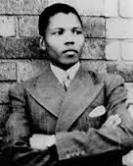
- Slideshow: Long Walk to Freedom
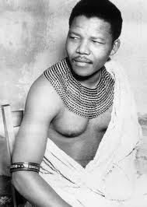

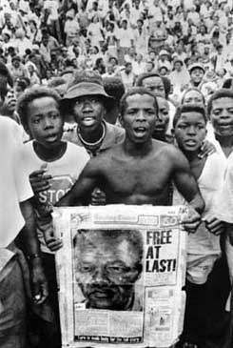

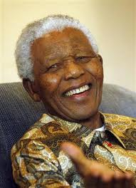

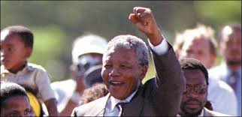

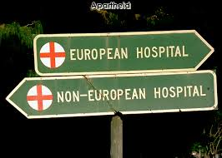
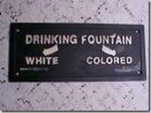
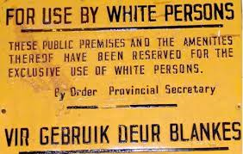
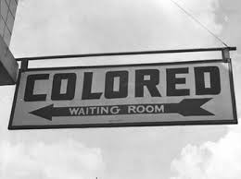
Apartheid
- 1994: South Africa WHY
- Miracle Rising

___________________________________________________________________________________________________________________________________________________________________________________________________________________________________________________________________________________________________________________________________________________________________________________________________________________________________________________________________________________________________________________________________________________________________________________________________________________________________________________________________________________________________________________________________________________________________________________________________________________________________________________________________________________________________________________________________________________________________________________________________________________________________________________________________________________________________________________________________________________________________________________________________________________________________________________________________________________________________________________________
Response: How does Mandela respond to the legacy of Apartheid?
Before Nelson Mandela was arrested in 1962, he was an angry, relatively young man. He founded the ANCs military wing. When he was released, he surprised everyone because he was talking about reconciliation and forgiveness and not about revenge. Desmond Tutu (http://www.brainyquote.com/quotes/keywords/reconciliation.html)

- Write a response to Invictus.
- Why does Mandela choose the path that he does?
- What does he hope to accomplish?
- Use this quote as the foundation of your response.
- Discuss reconciliation, forgiveness and revenge.

Notes from Invictus
Reconciliation | Forgiveness | Revenge

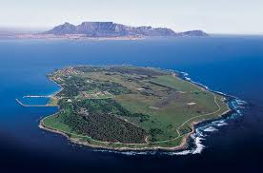
Invictus
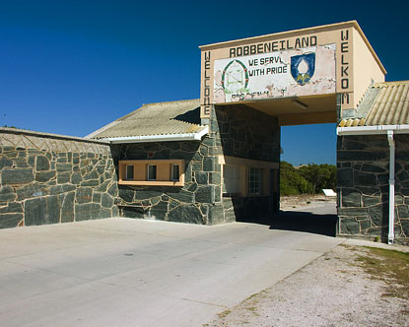
Out of the night that covers me,
Black as the Pit from pole to pole,
I thank whatever gods may be
For my unconquerable soul.
In the fell clutch of circumstance
I have not winced nor cried aloud.
Under the bludgeonings of chance
My head is bloody, but unbowed.
Beyond this place of wrath and tears
Looms but the Horror of the shade,
And yet the menace of the years
Finds, and shall find, me unafraid.
It matters not how strait the gate,
How charged with punishments the scroll.
I am the master of my fate:
I am the captain of my soul.
William Ernest Henley

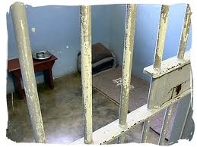
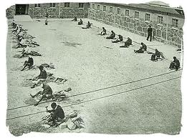
http://www.poemhunter.com/poem/invictus/

