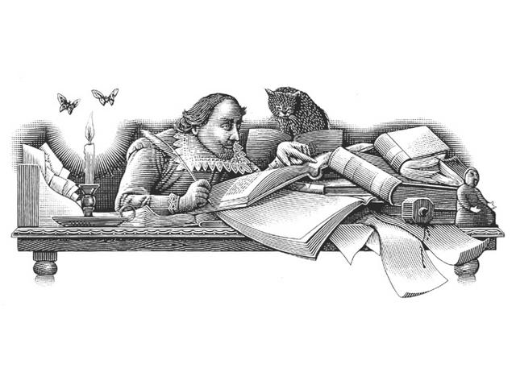

Othello
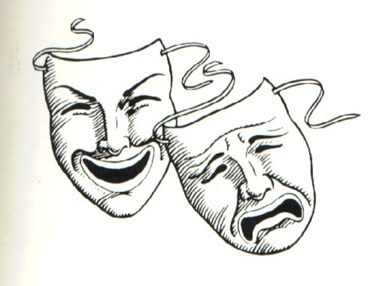
William Shakespeare
Oh, beware, my lord, of jealousy!
It is the green-eyed monster which doth mock
The meat it feeds on.
(Othello, Act 3, Scene 3)

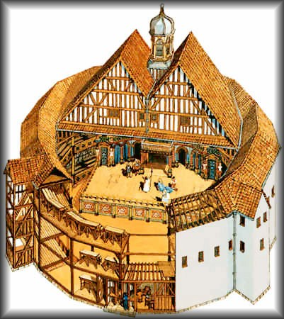
The Globe Theatre

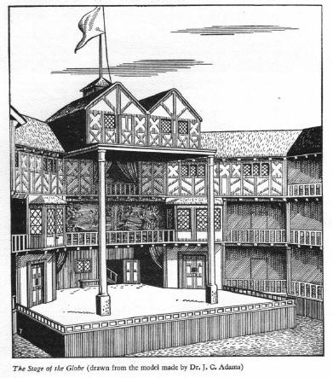

Great Chain of Being: Elizabethan World View

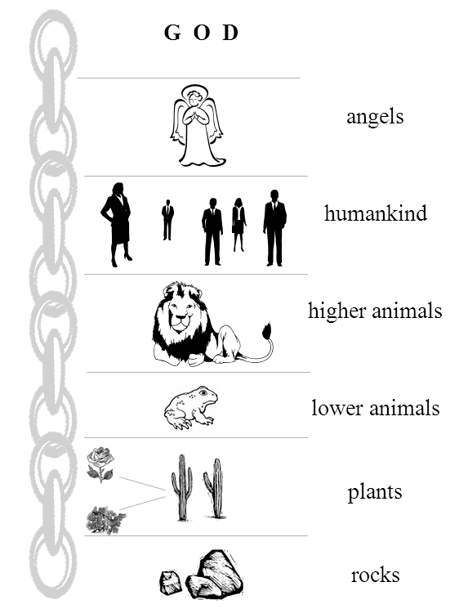

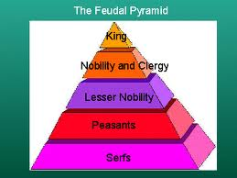

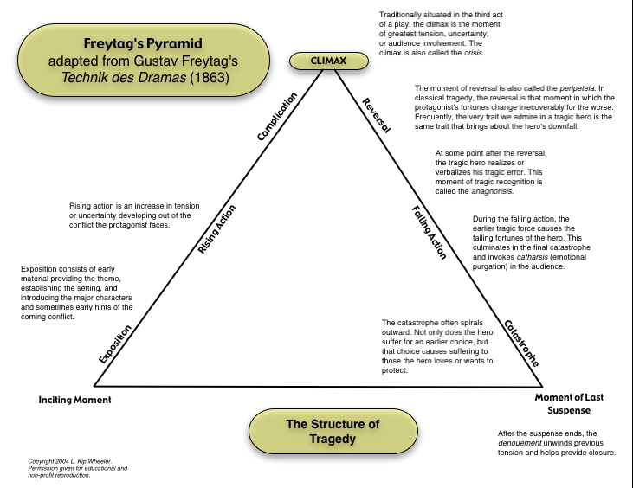

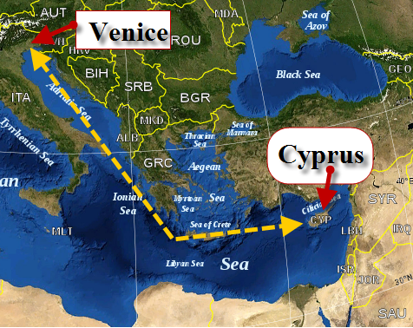
Othello Maps

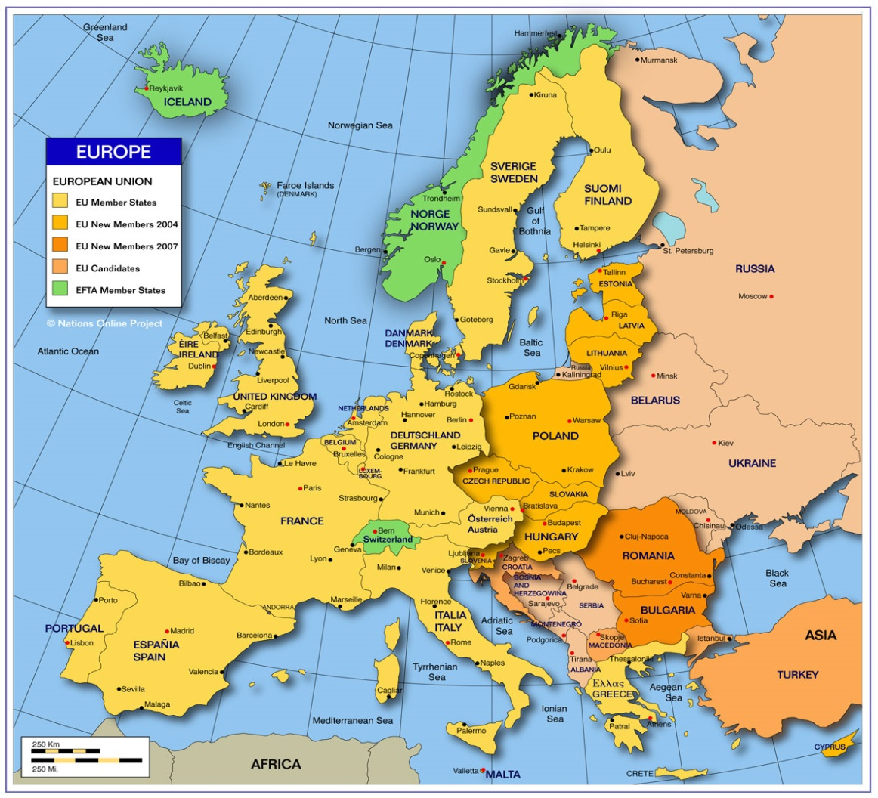

The Tragic Hero

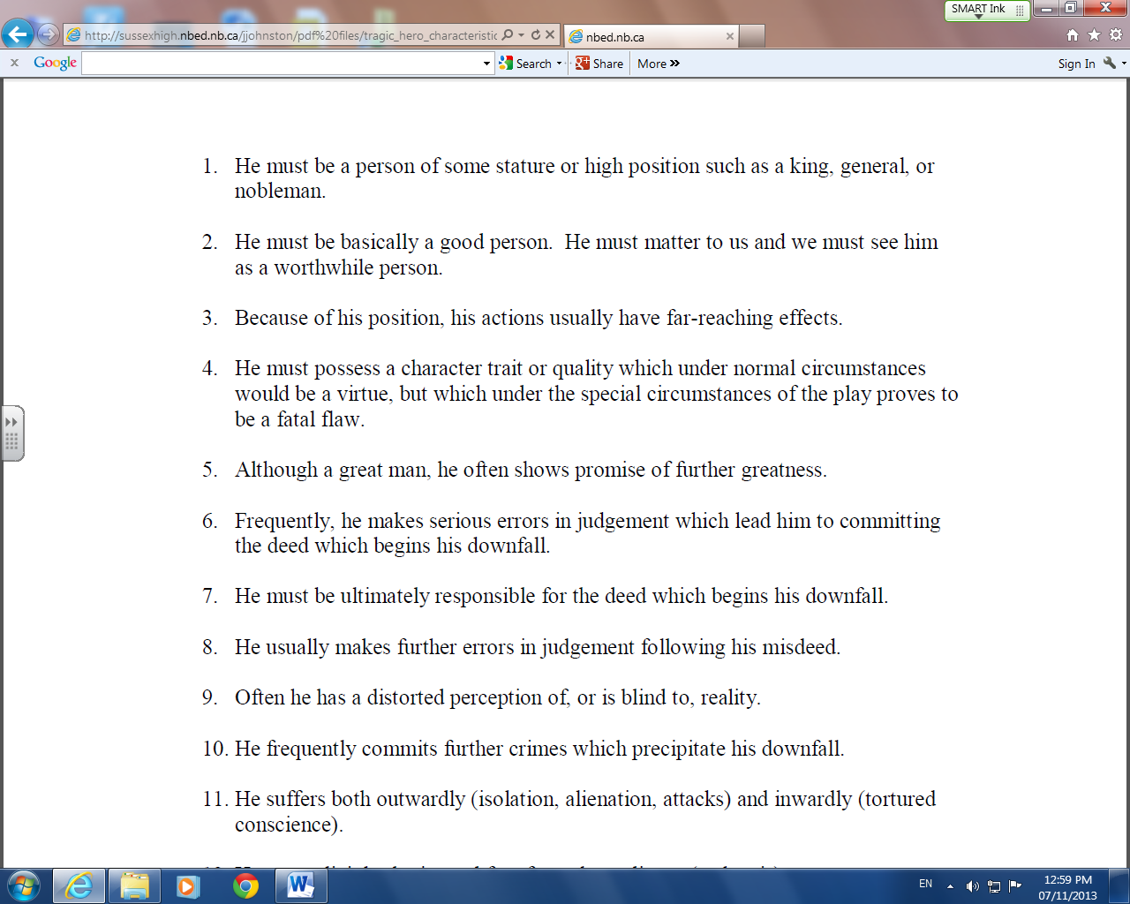

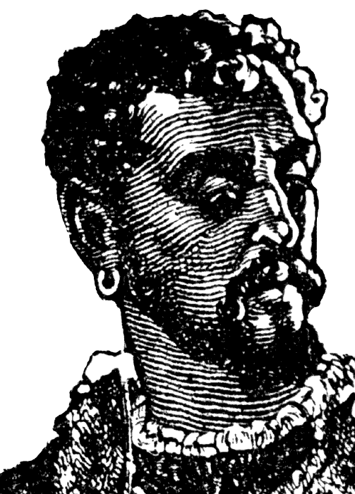

Identify and explain Othello’s tragic flaw.

Structure of Othello

Use the following chart to keep a summary of the main action of the play.
Element | Plot Events and Significance
Exposition | Outline 5 essential facts from Act I, scenes i-iii
Exciting Force | Act I, scene iii
Rising Action | Acts II and III
Climax | Indicate the event(s) from Act III that you consider to be the climax of the play.  Provide a reason for your choice
Falling Action | Acts III-IV
Conclusion | Indicate and describe the event(s) that mark the conclusion for the characters- not just Othello.

One of the most difficult tasks to understanding Shakespearean plays is being able to decipher, paraphrase, and analyze the meaning of character’s dialogue with each other and to the audience (through asides and soliloquys).
This assignment will test your ability to decrypt the language and explain the meaning of the chosen speech.
Assignment:
- Choose a soliloquy from those provided.
  - You may work with a partner.

- Work with the soliloquy first:
  - Chunk the lines to explain the text
  - Paraphrase
  - Identify key symbols or motifs
  - Identify imagery

- Create a cartoon, using Pixton (an on-line comic generator).
- Bring the soliloquy to life, using modern language and visuals to enhance meaning.
OR
- Create an annotated version of the soliloquy in a word document.
- Show the chunking, paraphrase, symbols and imagery (use visuals)
IAGO:
And what's he then that says I play the villain,
When this advice is free I give, and honest,
Probal to thinking, and indeed the course
To win the Moor again? For 'tis most easy
Th' inclining Desdemona to subdue
In any honest suit; she's framed as fruitful
As the free elements. And then for her
To win the Moor--were't to renounce his baptism,
All seals and symbols of redeemed sin--
His soul is so enfettered to her love,
That she may make, unmake, do what she list,
Even as her appetite shall play the god
With his weak function. How am I then a villain
To counsel Cassio to this parallel course,
Directly to his good? Divinity of hell!
When devils will the blackest sins put on,
They do suggest at first with heavenly shows,
As I do now. For whiles this honest fool
Plies Desdemona to repair his fortune,
And she for him pleads strongly to the Moor,
I'll pour this pestilence into his ear:
That she repeals him for her body's lust;
And by how much she strives to do him good,
She shall undo her credit with the Moor.
So will I turn her virtue into pitch,
And out of her own goodness make the net
That shall enmesh them all.
(Iago's soliloquy, "Othello," Act 2, Scene 3, lines 336-362)

Othello:

This fellow's of exceeding honesty,
 | And knows all qualities, with a learned spirit,
 | Of human dealings. If I do prove her haggard, |  | 260
 | Though that her jesses were my dear heartstrings,
 | I'ld whistle her off and let her down the wind,
 | To pray at fortune. Haply, for I am black
 | And have not those soft parts of conversation
 | That chamberers have, or for I am declined
 | Into the vale of years,--yet that's not much--
 | She's gone. I am abused; and my relief
 | Must be to loathe her. O curse of marriage,
 | That we can call these delicate creatures ours,
 | And not their appetites! I had rather be a toad, |  | 270
 | And live upon the vapour of a dungeon,
 | Than keep a corner in the thing I love
 | For others' uses. Yet, 'tis the plague of great ones;
 | Prerogatived are they less than the base;
 | 'Tis destiny unshunnable, like death:
 | Even then this forked plague is fated to us
 | When we do quicken. Desdemona comes:
 | Re-enter DESDEMONA and EMILIA.
Othello, Act 3, Scene 3, lines 258-278

Othello Response

The following quotes relate to a number of themes from Othello. Choose one quote. Write a one page response indicating the relationship between the quote and the play. Be sure to include specific examples and quotes from the play.

- Revenge, at first though sweet,
Bitter ere long back on itself recoils.
(John Milton, 1608-1674, Paradise Lost)

- Jealousy, the jaundice of the soul.
(John Dryden, 1631-1700)

- All human actions have one or more of these seven causes: chance, nature, compulsion, habit, reason, passion, and desire.
(Aristotle)

- A wise man rules his passions, a fool obeys them.
(Publius Syrus, 85-43 B.C.)

- If you would win a man to your cause, first convince him that you are his sincere friend.
(Abraham Lincoln, 1809-1865)

Quick Writes

Responding

Jealousy
O, beware, my lord, of jealousy;
It is the green-eyed monster

_______________________________________________________________________________________________________________________________________________________________________________________________________________________________________________________________________________________________________________________________________________________________________________________________________________________________________________________________________________________________________________________________________________________________________________________________________________________________________________________________________________________________________________________________________________________________________________________________________________________________________________________________________________________________________________________________________________________________________________________________________________________________________________________________________________________________________________________________________________________________________________________________________________________________________________________________________________________________________________________________________________________________________________________________________________________________________________________________________________________________________________________________________________________________________________________________________________________________________________________________________________________________________________________________________________________________________________________________________________________________________________________________________________________________________________________________________________________________________________________________________________________________________________________________________________________________________________________________________________________________________________________________________________________________________________________________________________________________________________________________________________________________________________________________________________________________________________________________________________________________________________________________________________________________________________________________________________________________________________________________________________________________________________________________________________________________________________________________________________________________________________________________________________________________________________________________________________________________________________________________________________________________________________________________________________________________________________________________________________________________________________________________________________________________________________________________________________________________________________________________________________________________________________________________________________________________________________________________________________________________________________________________________________________________________________________________________________________________________________________________________________________________________________________________________________________________________________________________________________________________________________________________________________________________________________________________________________________________________________________________________________________________________________________________________________________________________________________________________________________________________________________________________________________________________________________
Reputation
It takes many good deeds to build a good reputation, and only one bad one to lose it.
-Benjamin Franklin

http://www.brainyquote.com/quotes/quotes/b/benjaminfr385547.html#BcoSRWxdQG2uv7zC.99

Be more concerned with your character than your reputation, because your character is what you really are, while your reputation is merely what others think you are.
-John Wooden

http://www.brainyquote.com/quotes/quotes/j/johnwooden163015.html#v1yuxH85CXSTrTHw.99

It takes 20 years to build a reputation and five minutes to ruin it. If you think about that, you'll do things differently.
-Warren Buffett

http://www.brainyquote.com/quotes/quotes/w/warrenbuff108887.html#JIYSo6QsYCm8MOXe.99





