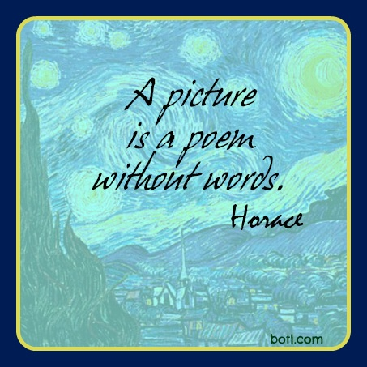
Photo Essay

https://www.pinterest.com/pin/539235755355179097/
Learning Goals:
- Expand interests in a range of genres and a variety of texts
- Describe text creator’s purpose; analyze target audience
- Analyze visual elements; explain how they contribute to meaning
  - Use appropriate vocabulary
- Relate form, structure and medium to purpose, audience and content
- Relate elements, devices and techniques to created effects
- Appreciate the effectiveness and artistry of nonprint texts
- Focus on purpose and presentation form
- Assess text creation context
- Use production, publication and presentation strategies and technologies consistent with context
- Cooperate with others, and contribute to group processes
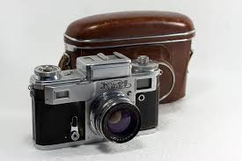
Photo Essay

A photo essay is a series of images linked by a common photo technique, concept, theme or purpose. In some way, the photos themselves either tell the story or contribute to the telling of the story. The relationship between the photos may be explicit, as in a sequence of images of a war-torn village, or less obvious, requiring the viewer to look for the connection.

The Assignment:

Create your own photo essay using photos you take yourself. Explore a subject that interests you. Do not be afraid to be experimental with your photography. (Think of important upcoming events in your life, travel at Easter, pop culture in your life, a significant person in your life….)

Remember that the artistry of the photo essay lies not only in taking the photographs and writing the captions, but also in arranging the photos in sequence, and in positioning photos and text on the page.

The Requirements:
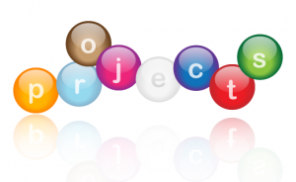
  - A written introductory paragraph that introduces your overall idea, its relevance, and prepares the audience for the photos.
  - 8 to 10 photos
  - A caption beneath each photo
  - An original title
  - Attractive display/presentation
  - Critical analysis of the creation process
    - This is a separate written explanation of your motivation, process, feelings about the outcome

The Process:

- As a class:

  - We will view the photo essay “Mean Streets”
  - http://www.thephotoessay.com/chiyin/v1.html
  - Discuss the dimensions of a photo essay and the possibilities

- As a small group:

- You will view the photo essay “This is What it Looks Like at the Centre of America”
- http://www.nytimes.com/slideshow/2013/12/08/magazine/08greatplains_ss.html?ref=magazine#1
- Analyze the photos
  - As assigned

https://docs.google.com/a/phrd.ab.ca/presentation/d/1vkIMM3YBXrmTMQ3w5jDfGae7cuwgyL5I23wTYD2aBGI/edit#slide=id.g6e1256935_037

- Complete the viewing guide (attached)

- As an individual:

- Create your own photo essay.
********************************************************

Support material

- “Five types of photos that make for strong photo essays”
http://www.poynter.org/how-tos/visuals/171050/5-types-of-photos-that-make-for-strong-photo-essays-audio-slideshows/

- “The Secret of Creating a Strong Image- 5 Tips for Creating a Story in Your Image” (access through my website)
http://digital-photography-school.com/the-secret-of-creating-a-strong-image-5-tips-for-creating-a-story-in-your-image/

- “The Twelve Most Amazing Photo Essays of 2013”
http://www.fastcoexist.com/3023643/the-12-most-amazing-photo-essays-of-2013#8

A Comparison of Two Photo Essays:
“Mean Streets” & “This is What it Looks Like at the Centre of America”
 | “Mean Streets” | “This is What it Looks Like at the Centre of America”
Context
Time
Place

Summary

Aspects of Life Shown

Purpose of Photo Essay
Effect of Photo Essay
Which photo stands out the most for you? Why?
What story is told?
What emotion(s) is/are created?

What conclusions can you draw about photo essays?

Regardless of what type of photo essay you choose to present, the following elements should be considered during its creation:
- The story- Your essay should be able to stand alone, without a written article, and make logical sense to the viewer.
- A range of photos: A variety of photos (wide angle, detailed, portraits etc.) should be included. See the types of photos section discussed below.
- The order of the photos: It is important that the order of your photos effectively tell a story, in an interesting and logical sequence.
- Information and emotion: Your photos should include both informational and emotional photos. Those essays that effectively evoke emotion while providing information tend to convey their messages the best.
- Captions: In a photo essay, captions are your best opportunity to describe what is happening in words and ensure that the viewer understands. Include informational content in these captions if necessary.
Types of Photos
By including a variety of types of photos in your essay, you will ensure that it is both interesting and informative. The following types of photos, presented together, can create a successful photo essay. Not only is it important to choose powerful photos, but also to present them in an effective order. While the order of some photos (e.g. the lead photo, and the clincher) is set, the order of most types of photos in your essay is your preference.
The Lead Photo: Similar to the first two sentences of a newspaper article, your lead photo should effectively draw in your audience. This is usually the most difficult photo to choose and should follow the theme of your essay. It could be an emotional portrait or an action shot, but ultimately it should provoke the curiosity of the viewer.
The Scene: Your second photo should set the stage and describe the scene of your story. An overarching photo taken with a wide angle lens is often effective.
The Portraits: Your photo essay should include at least one portrait. Capturing an emotional expression or telling action shot can effectively humanize your story. These photos often evoke strong emotions and empathy in the viewer (whether it is a positive and enthusiastic emotion, or a sympathetic and concerned emotion.)
The Detail Photos: Detail photos focus in on one element, be it a building, a face, or a relevant object. These photos are your best opportunity to capture specific objects. The captions of these photos should be informative and educational.
The Close-up Photos: Similarly, close-up photos provide an opportunity to focus in on specific objects. These photos are tightly cropped, simple shots that present a specific element of your story. Again, this is an excellent opportunity to present information in the caption.
The Signature Photo:The signature photo summarizes the situation and captures the key elements of your story in a telling moment.
The Clincher Photo: The final photo, the clincher, should evoke the emotion you want the viewer to walk away with, be it a feeling of hope, inspiration, or sadness. Decide on this mood before you select this photo.
Remember, these suggestions are only guidelines. Photo essays are a form of art, and like any artistic creation, breaking the rules can sometimes create the most powerful result.
https://docs.google.com/a/phrd.ab.ca/document/d/1uOwFCpUGmzqr15AEWXMxx6667hviL4S0NdHj0gof1jY/edit
Analyzing a Photo
Photographers create meaning and impact in their photographs through the choices they make about visual elements and design. Use the following to analyze the photograph your group has been assigned.
http://nuovo.com/southern-images/analyses.html (explains the terms used below)
What is the subject of the photograph?

Where did the photograph originally appear?

What is the dominant mood or feeling of the photograph?

Features of the photograph:

- Choice of images

- Camera angle

- Composition

- Focal point

- Focus (are all parts of the photo in focus?)

- Colour (how does colour create focal point or mood?)

- Light and shadow

Photo Essay Marking Key

 | 1 2 3 4 5
Content (x2) | - Title  - Sense of purpose and audience: engages the reader  - Conveys a meaningful and relevant central idea  - Offers some depth, complexity, and/or sophistication in message  - Enhances the message with relevant images and words  - Includes the minimum number of pictures (6 – 10)  - Each picture includes a relevant caption
Presentation (Composition) | - Selection of images and words show understanding of elements of design (colour, space, line, shape)  - Material is organized with attention to visual elements (contrast, patterns, unity)  - Attention to detail: correct spelling, grammar  - Organization- flows
Creative thinking/risk taking | - Impact on audience  - Includes unusual or unexpected elements/features  - Degree of risk  - Originality, creativity
Critical Analysis | - Explain the process of creating the essay and the choices you made.  - Extensive and detailed explanation.  - Inspiration?  - Purpose and audience (what did you want to accomplish? Who is this intended for?)  - Organization?  - Photo choices?  - Did you take photos specifically for this, use photos you had taken at another time, or both?  - Colour and detail choices (have you used particular paper or background? Why?)  - Have you made font choices, added other details for effect?  - Did you include an introduction or conclusion? Why?

Key:

1 = insufficient/poor
- Missing or off topic

2 = Limited
- The elements are there, but show little relationship, do not have depth (superficial)

3 = Satisfactory
- Some skill is shown
- The basic requirements have been met

4 = Proficient
- Clear and considerable purpose, details
- Considerable skill shown
- Depth is apparent

5 = Excellent/Superior
- Strong, well-thought-out
- High degree of understanding, use of technique
- Extensive command of expectations
- May include symbolic levels

