tuesdays with Morrie
Mitch Albom

an old man, a young man, and life’s greatest lessons
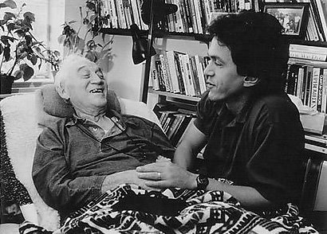

Thinking through reading and responding
Section 1: Pg # - 1-54
- Two light bulb moments from this section
1)

2)

Choose one of your light bulb moments and reflect on why this moment resonated with you. _________________________________________________________________________________________________________________________________________________________________________________________________________________________________________________________________________________________________________________________________________________________________________________________________________________________________________________________________________________________________________________________________________________________________________________________________________________________________________________________________________________________________________________________________________________________________________________________________________________________________________________________________________________________________________________________________________________________________________________________________________________________________________________________________________________________________________________________________________________________________________________________________________________________________________________________________________________________________________________________________
Reflect: to think deeply, or carefully about (http://tinyurl.com/l7pjw6m)
Synonyms: consider, mull over, contemplate, meditate on (http://tinyurl.com/lgfojcp)
Section 2: Pg # - 55-113
Two light bulb moments from this section
1)

2)

Choose one of your light bulb moments and reflect on why this moment resonated with you.
__________________________________________________________________________________________________________________________________________________________________________________________________________________________________________________________________________________________________________________________________________________________________________________________________________________________________________________________________________________________________________________________________________________________________________________________________________________________________________________________________________________________________________________________________________________________________________________________________________________________________________________________________________________________________________________________________________________________________________________________________________________________________________________________________________________________________________________________________________________________________________________________________________________________________________________________________________________________________________________________________________________
Section 3: Pg # - 114-192
Two light bulb moments from this section
1)

2)

Choose one of your light bulb moments and reflect on why this moment resonated with you.
__________________________________________________________________________________________________________________________________________________________________________________________________________________________________________________________________________________________________________________________________________________________________________________________________________________________________________________________________________________________________________________________________________________________________________________________________________________________________________________________________________________________________________________________________________________________________________________________________________________________________________________________________________________________________________________________________________________________________________________________________________________________________________________________________________________________________________________________________________________________________________________________________________________________________________________________________________________________________________________________________________________
After Reading:
- Thinking through questions:
  - In your reading group, develop 5 questions based on Bloom’s Taxonomy.

___________________________________________________________________

- Thinking through writing:
- Online Discussion Forum
  - Choose one of your light bulb moments from any section.
  - Share this, and your reflection, through Mrs. Raymond’s blog. www.raymondsenglishroom.blogspot.ca (use Chrome)

  - Respond to at least two other responses.

- Thinking through creativity
  - Create a recipe for life

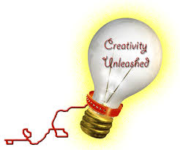
      - Consider the wisdom that is offered in Tuesdays with Morrie

      - Consider your own ideas

      - Create a recipe that includes the ingredients, the instructions, and the final product, and a name

      - Include a visual element that highlights the “final product”

___________________________________________________________________

- Thinking through critical response
What idea(s) and impressions does Mitch Albom’s tuesdays with Morrie suggest regarding the significance of a new perspective?

- Consider your controlling idea (thesis).
- What pattern of organization will you use? (form and structure)
- What support and evidence will you use?
  - Include direct quotes from tuesdays with Morrie
  - Include a bibliography

